CAPSTON PROJECT

PNEUMONIA DETECTION CHALLENGE

Contents

Summary of problem statement, data and findings 4

Overview 4

Problem Statement 5

Data and findings 5

Initial Steps & EDA 6

Reading CSVs 6

Observations from the CSVs 9

Reading Images 10

Observations from dicom image files 10

Identify the unique body part- 11

Recognizing Different Points of View 11

Observations: BodyPartExamined & ViewPosition 14

Checking outliers in `PatientAge 14

Age Binning 16

Exploring the bounding boxes centers for `AgeBins` 17

Distribution of age for those with Pneumonia Evidence, by Gender & Count Plot of Gender 18

Observations: PatientAge & PatientSex 20

View the images 20

Modeling 22

Model Approach -1 22

Model Testing 27

Mask R-CNN 27

Architecture of Mask R-CNN 27

Problem Solving 28

YOLOv5 41

What is YOLOv5 41

YOLOv5 Architecture 42

Why Yolov5- 43

Bounding box in Yolov5 format : 43

Training and Results: 44

FINAL BEST MODEL(With hyperparameter tuning) 47

SUMMARY AND CONCLUSION: 52

Data preparation: 52

Training: 52

Output: 53

Appendix 54

GITHUB 54

# Summary of problem statement, data and findings

## Overview

Pneumonia accounts for over 15% of all deaths of children under 5 years old internationally. In 2015, 920,000 children under the age of 5 died from the disease. In the United States, pneumonia accounts for over 500,000 visits to emergency departments [1] and over 50,000 deaths in 2015 [2], keeping the ailment on the list of top 10 causes of death in the country.

While common, accurately diagnosing pneumonia is a tall order. It requires review of a chest radiograph (CXR) by highly trained specialists and confirmation through clinical history, vital signs and laboratory exams. Pneumonia usually manifests as an area or areas of increased opacity [3] on CXR. However, the diagnosis of pneumonia on CXR is complicated because of a number of other conditions in the lungs such as fluid overload (pulmonary edema), bleeding, volume loss (atelectasis or collapse), lung cancer, or post-radiation or surgical changes. Outside of the lungs, fluid in the pleural space (pleural effusion) also appears as increased opacity on CXR. When available, comparison of CXRs of the patient taken at different time points and correlation with clinical symptoms and history are helpful in making the diagnosis.

CXRs are the most commonly performed diagnostic imaging study. A number of factors such as positioning of the patient and depth of inspiration can alter the appearance of the CXR [4], complicating interpretation further. In addition, clinicians are faced with reading high volumes of images every shift.

To improve the efficiency and reach of diagnostic services, the [Radiological Society of North America (RSNA®)](http://www.rsna.org/) has reached out to Kaggle’s machine learning community and collaborated with the [US National Institutes of Health](https://www.nih.gov/), [The Society of Thoracic Radiology](http://thoracicrad.org/), and [MD.ai](https://www.md.ai/) to develop a rich dataset for this challenge.

## Problem Statement

Pneumonia is a lung infection that necessitates the review of a chest radiograph by highly trained specialists. Pneumonia appears as an area of opacity on a chest radiograph. However, diagnosing it can be difficult, and specialists spend a lot of time and effort reviewing them. The most common diagnostic imaging study is a chest radiograph. Because of the high volume of chest radiography, radiologists must spend a significant amount of time and effort manually reviewing each image. As a result, an automated solution is ideal for determining the location of inflammation in an image. The use of an automated pneumonia screening system can help physicians make better clinical judgment or even replace human judgement in this area.

## Data and findings

The data is provided in the form of a zip file called "rsna-pneumonia-detection-challenge.zip," which includes the following items:

1. A folder called "stage 2 train images" contains all of the training dataset chest radiograph DICOM images.
2. "stage 2 train labels.csv" is a csv file: This file contains the corresponding patientID images to the folder "stage 2 train images," as well as the bounding box of areas of pneumonia detected in each image, as well as a target label of 0 or 1 for pneumonia detected.
3. "stage 2 detailed class info.csv" is a csv file: This file contains the target class labels for the images in the folder "stage 2 train images" and contains the corresponding patientID images.
4. A folder called "stage 2 test images" contains all of the test dataset chest radiograph DICOM images. We will not be using this set of images because they lack labels.
5. "stage 2 sample submission.csv" is a csv file: This file contains the patientID images that correspond to the folder "stage 2 test images." This set of files will not be used.

# Initial Steps & EDA

As part of the EDA, we will:

* Begin by learning about the data, including train/test labels and class information.
* Examine the first five rows of each csv files (train and test)
* Determine how classes and targets are distributed.
* Use the 1, 2,... bounding boxes to count the number of patients.
* Dicom files can be read and metadata extracted.
* Analyze some of the properties found in dicom files.
* Take a look at some random photographs from the training set.
* Draw conclusions from the data at various phases of the EDA process.

The project will be completed on Google Colab to aid in the development of a neural network.

The first step is to download and unzip the zip file in order to access the files listed above in the Google Drive directory.

The second step is to confirm that the images provided are all DICOM images in the ".dcm" file format. Here we used the pydicom library to open and read the DICOM images. The subsequent step would be to inspect the csv files.

## Reading CSVs

* Images for the current stage in the stage_2_train_images and stage_2_test_images.
* Training data: stage_2_train_labels.csv
* stage_2_detailed_class_info.csv containing detailed information about the positive and negative classes in the training set

After analyzing we found that

***Train Labels dataframe has 30227 rows and 6 columns***

***Class info dataframe has 30227 rows and 2 columns***

***Number of duplicates in patientID in train labels dataframe: 3543***

***Number of duplicates in patientID in class info dataframe: 3543***

-------------------- First five rows of both dataframes (train_labels, class_info) --------------------

* Train labels dataframe:

|  | **patientId** | **x** | **y** | **width** | **height** | **Target** |
| --- | --- | --- | --- | --- | --- | --- |
| **0** | 0004cfab-14fd-4e49-80ba-63a80b6bddd6 | NaN | NaN | NaN | NaN | 0 |
| **1** | 00313ee0-9eaa-42f4-b0ab-c148ed3241cd | NaN | NaN | NaN | NaN | 0 |
| **2** | 00322d4d-1c29-4943-afc9-b6754be640eb | NaN | NaN | NaN | NaN | 0 |
| **3** | 003d8fa0-6bf1-40ed-b54c-ac657f8495c5 | NaN | NaN | NaN | NaN | 0 |
| **4** | 00436515-870c-4b36-a041-de91049b9ab4 | 264.0 | 152.0 | 213.0 | 379.0 | 1 |

* Class info dataframe:

|  | **patientId** | **class** |
| --- | --- | --- |
| **0** | 0004cfab-14fd-4e49-80ba-63a80b6bddd6 | No Lung Opacity / Not Normal |
| **1** | 00313ee0-9eaa-42f4-b0ab-c148ed3241cd | No Lung Opacity / Not Normal |
| **2** | 00322d4d-1c29-4943-afc9-b6754be640eb | No Lung Opacity / Not Normal |
| **3** | 003d8fa0-6bf1-40ed-b54c-ac657f8495c5 | Normal |
| **4** | 00436515-870c-4b36-a041-de91049b9ab4 | Lung Opacity |

* Numbers of nulls in bounding boxes columns are equal to the 0s we've in Target column

--------------------------------------------------------------------------------

Checking nulls in bounding boxes columns: {'x': 20672, 'y': 20672, 'width': 20672, 'height': 20672}

Checking value counts for the targets: {0: 20672, 1: 9555}

* The distribution of `Target` and `class` column

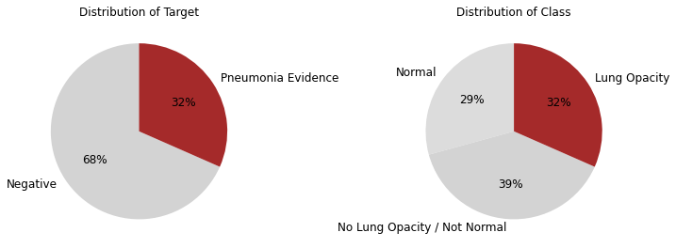

* Group by patient IDs and check number of bounding boxes for each unique patient ID

--------------------------------------------------------------------------------

Number of unique patient IDs in the dataset: 26684

Number of patientIDs per bboxes in the dataset

Out[10]:

|  | **number_of_patientIDs_per_boxes** |
| --- | --- |
| **number_of_boxes** |  |
| **1** | 23286 |
| **2** | 3266 |
| **3** | 119 |
| **4** | 13 |

each patientId is associated with only 1 class

Shape of the dataset after the merge: (30227, 8)

train_class.head()

|  | **patientId** | **x** | **y** | **width** | **height** | **Target** | **number_of_boxes** | **class** |
| --- | --- | --- | --- | --- | --- | --- | --- | --- |
| **0** | 0004cfab-14fd-4e49-80ba-63a80b6bddd6 | NaN | NaN | NaN | NaN | 0 | 1 | No Lung Opacity / Not Normal |
| **1** | 00313ee0-9eaa-42f4-b0ab-c148ed3241cd | NaN | NaN | NaN | NaN | 0 | 1 | No Lung Opacity / Not Normal |
| **2** | 00322d4d-1c29-4943-afc9-b6754be640eb | NaN | NaN | NaN | NaN | 0 | 1 | No Lung Opacity / Not Normal |
| **3** | 003d8fa0-6bf1-40ed-b54c-ac657f8495c5 | NaN | NaN | NaN | NaN | 0 | 1 | Normal |
| **4** | 00436515-870c-4b36-a041-de91049b9ab4 | 264.0 | 152.0 | 213.0 | 379.0 | 1 | 2 | Lung Opacity |

### Observations from the CSVs

Based on analysis above, some of the observations:

* Patient Ids and bounding boxes are included in the training data. The dimensions of bounding boxes are x, y, width, and height.
* For each patient, there are many records. There are 3,543 duplicates in patientID.
* There is also a binary target column, with Target indicating whether there was definitive evidence of pneumonia or not.
* The following classes are included in the class label: No Lung Opacity/Not Normal, Normal, and Lung Opacity.
* Lung Opacity class is associated with chest examinations with Target = 1, i.e. those with indications of Pneumonia.
* Chest examinations with Target = 0 (no clear evidence of Pneumonia) are classified as Normal or No Lung Opacity / Not Normal.
* A total of 23,286 patientIds (87%) have one bounding box, whereas 13 patients have four bounding boxes.

## Reading Images

DICOM (.dcm) is an international standard for transmitting, storing, retrieving, printing, processing, and displaying medical imaging information. Medical imaging data is made shareable thanks to the Digital Imaging and Communications in Medicine (DICOM) standard. To read the images, we will utilise the pydicom package.

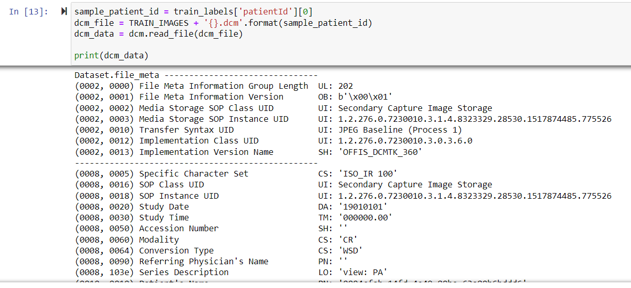

### Observations from dicom image files

We can see from the above sample that the dicom file has certain data that may be used for further analysis, such as sex, age, body part investigated (which should primarily be the chest), view location, and modality. This image has a resolution of 1024 by 1024 pixels (rows x columns).

**Extraction of features from dicom picture files**

We found some elements from the dicom files that can be explored/used above; now let's focus on the image file analysis.

* Understand the age distribution for those with evidence of lung opacity and those without definite evidence of lung opacity.
* Understand the male and female distribution for those with evidence of lung opacity and those without definite evidence of lung opacity.
* Explore different view positions in the dataset.

We'll utilized the function ('get tags') defined in ('eda') to extract features from dicom image files.

Merge path from the `images` dataframe with `train_class` dataframe

Shape of the `train_class` dataframe after merge: (30227, 9)

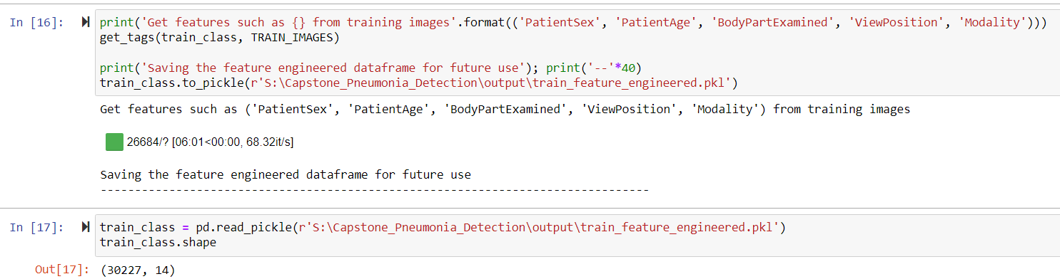

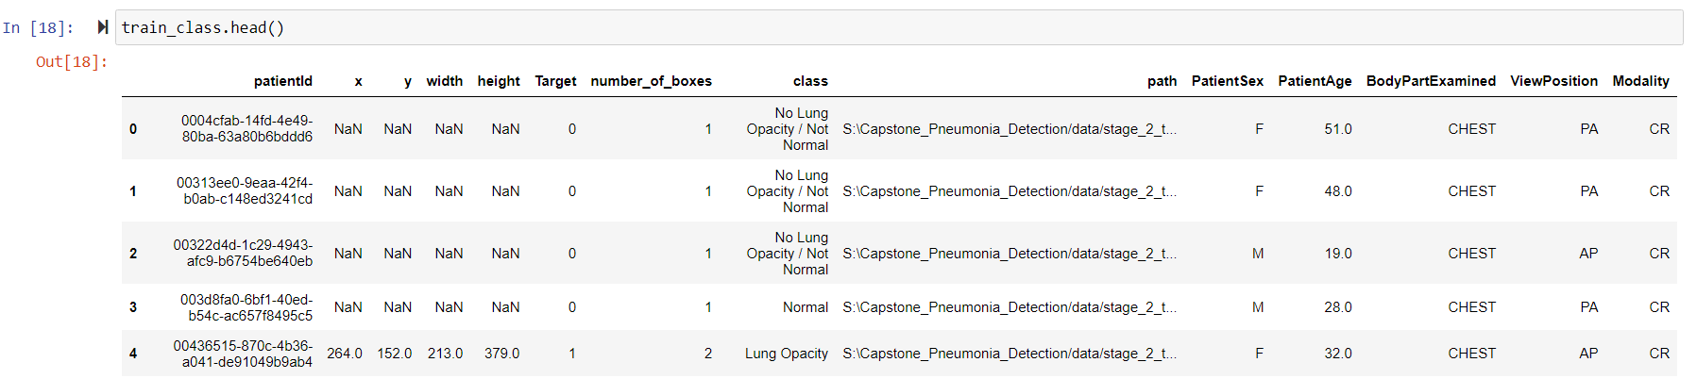

### Identify the unique body part-

As expected, unique in `BodyPartExamined` is: CHEST

Unique in `Modality` is: CR

### Recognizing Different Points of View

The training dataset has two View Positions: AP (Anterior/Posterior) and PA (Posterior/Anterior), as shown below. These X-rays are typically utilised to obtain a front-view image. A lateral picture is frequently taken in addition to the front-view to complement the front-view.

* **Posterior/Anterior (PA)**: In PA, the X-Ray beam strikes the posterior (back) section of the chest first, followed by the anterior (front). The patient is requested to stand with their chest against the film while the image is being taken.
* **Anterior/Posterior (AP)**: Sometimes radiographers are unable to get a PA chest X-ray. This is mainly due to the patient's inability to stand. The quality of AP projection images is poorer than that of PA projection images. The size of the heart is exaggerated (cardiothoracic ratio approximately 50 percent )

Below Pie chart shows the distribution in detail.

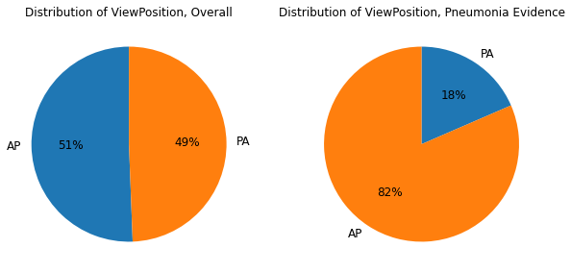

* Exploring the bounding boxes for both view positions

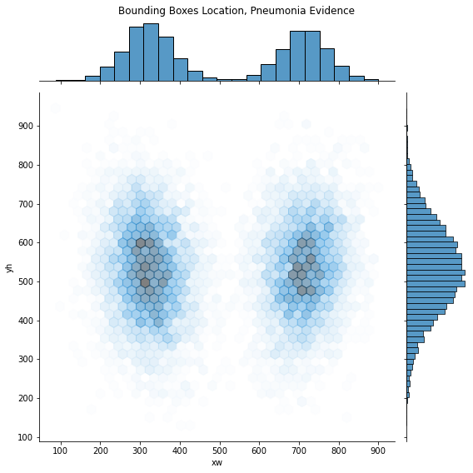

Exploring the bounding boxes centers for `ViewPositions` for random sample = 1000

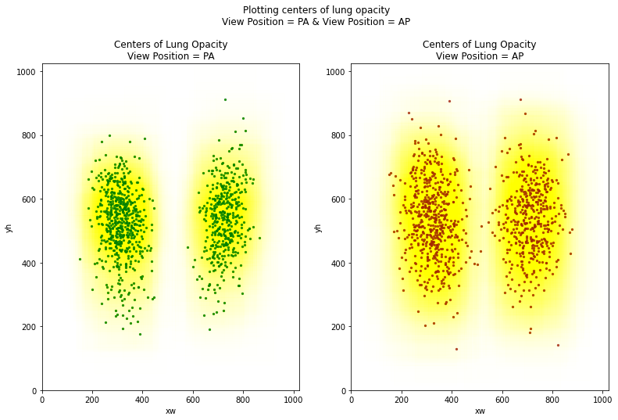

### Observations: BodyPartExamined & ViewPosition

*'BodyPartExamined' is unique for all instances and CHEST in the training dataset, as we observed above, which was also expected.

Overall, 'ViewPosition' is almost evenly distributed in the training dataset, however for cases where 'Target=1', the majority of the view positions are 'AP'.

### Checking outliers in `PatientAge

Minimum `PatientAge` in the training dataset: 1.0

Maximum `PatientAge` in the training dataset: 155.0

75th Percentile of `PatientAge` in the training dataset: 59.0

`PatientAge` in upper whisker for box plot: 84.0

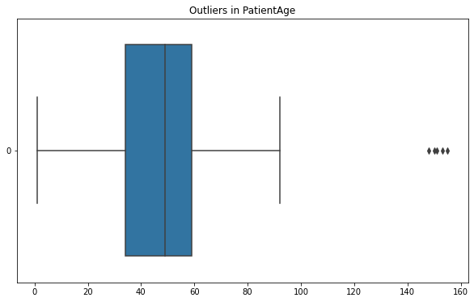

'pd.clip()' used to trim a number to a defined lower and upper threshold. As a result, a PatientAge higher threshold of 100 would result in those outlier numbers being transformed to 100

Below image shows distribution of all and pneumonia positive patients

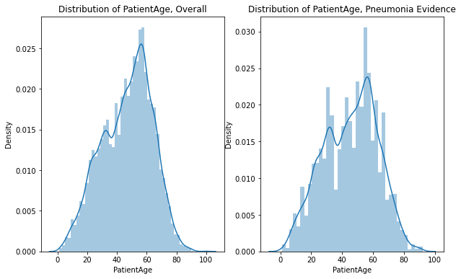

### Age Binning

**For the 'PatientAge' functionality, we're using the Binning Method**

We'used a command called 'pd.cut,' which means 'Bin values into discrete intervals.' When you need to split and sort data values into bins, this method is recommended. This function can also be used to convert a continuous variable to a categorical one. Binning into an equal number of bins or a pre-defined array of bins is supported.

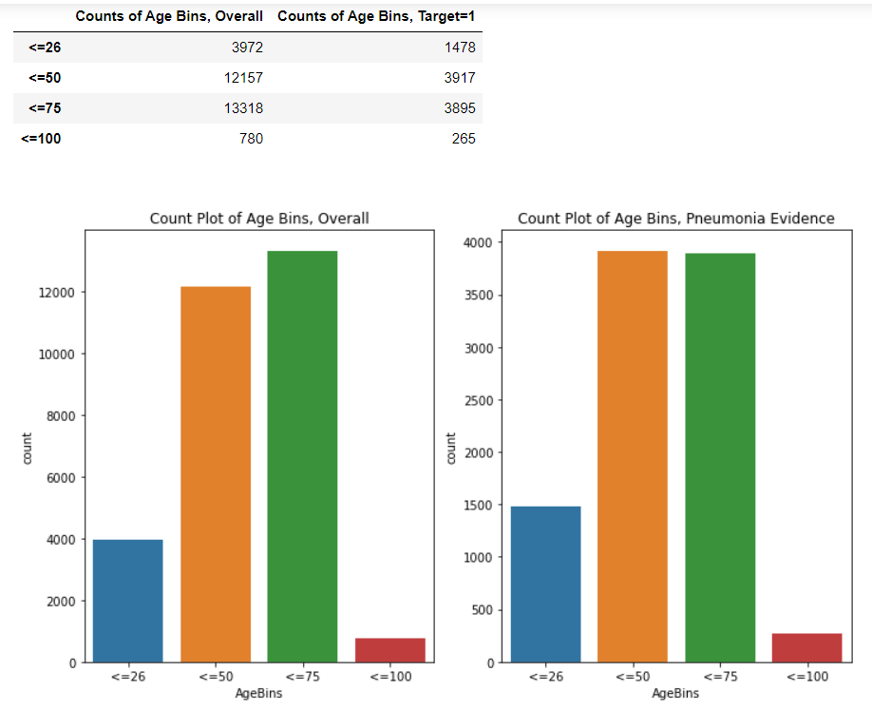

### Exploring the bounding boxes centers for `AgeBins`

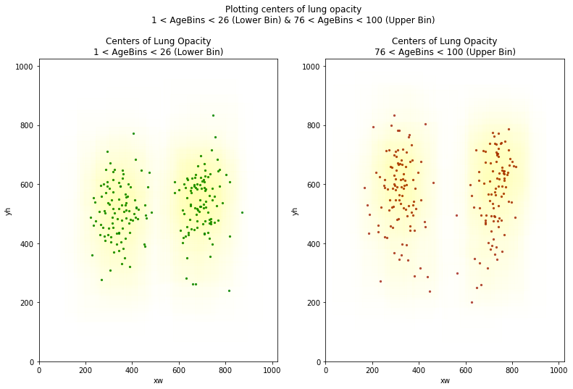

### Distribution of age for those with Pneumonia Evidence, by Gender & Count Plot of Gender

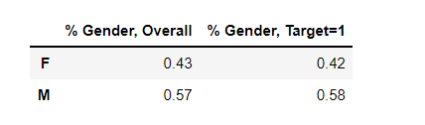

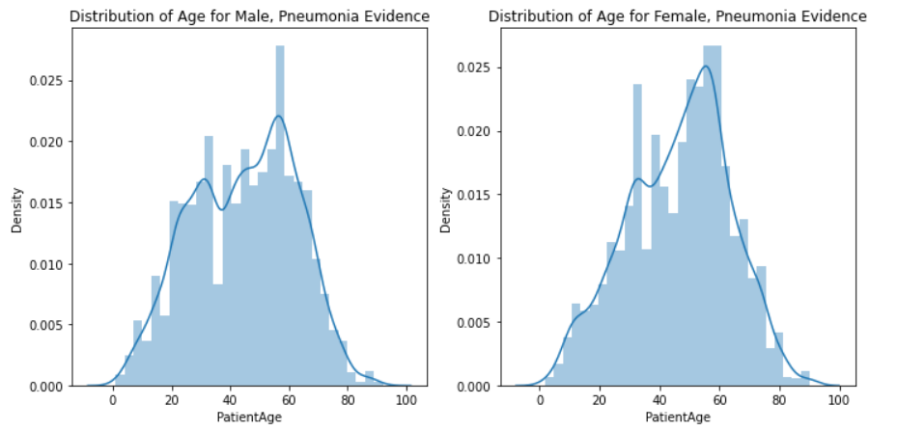

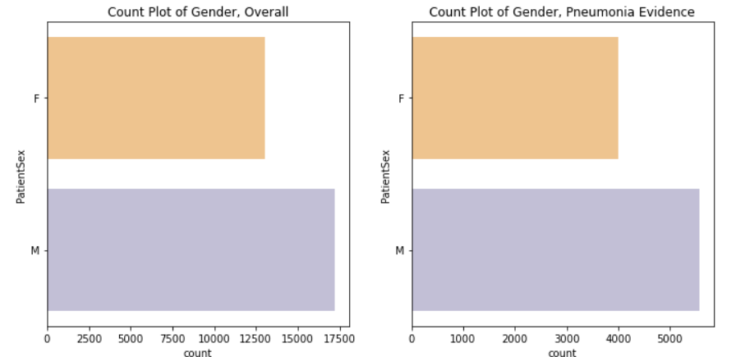

*Exploring the bounding boxes centers for `PatientSex*`

We used random sample =100 here

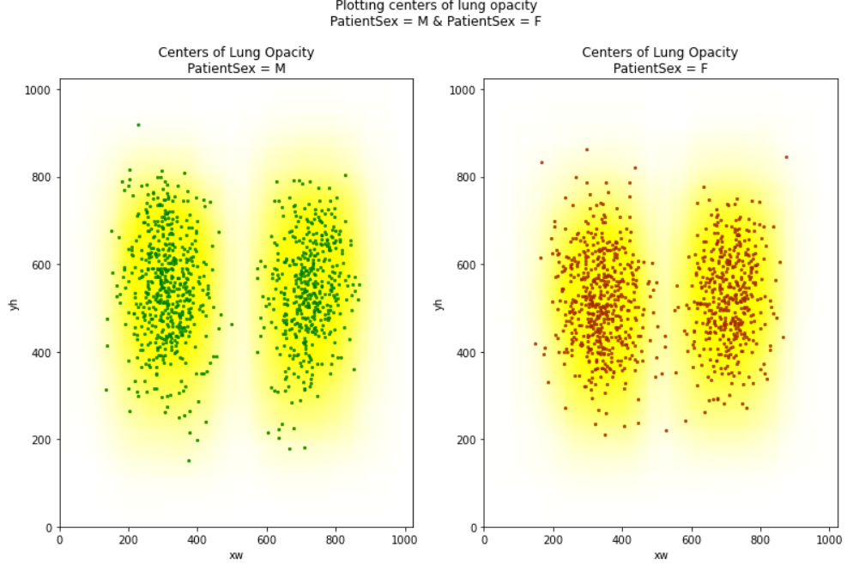

### Observations: PatientAge & PatientSex

Above we saw,

* For PatientAge we saw the distribution for both overall and where there were evidence of Pneumonia. Used binning to check the count of age bins. Count was highest for age group 40-78 both overall and with Pneumonia Evidence.
* Saw distribution of age for Male and Female with Pneumonia Evidence.
* Dataset had more Males (57%-58%) than Females (42%-43%).

Only PatientAge, PatientSex and ViewPosition are useful features from metadata.

### View the images

To view the images, we utilized the custom module ('eda') and function ('plot dicom images') that we imported earlier.

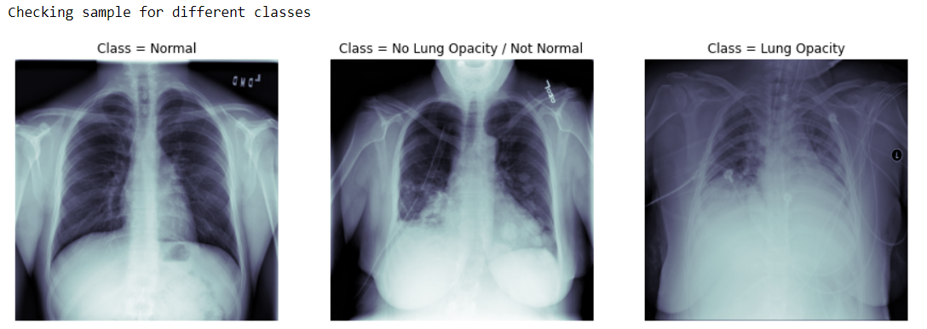

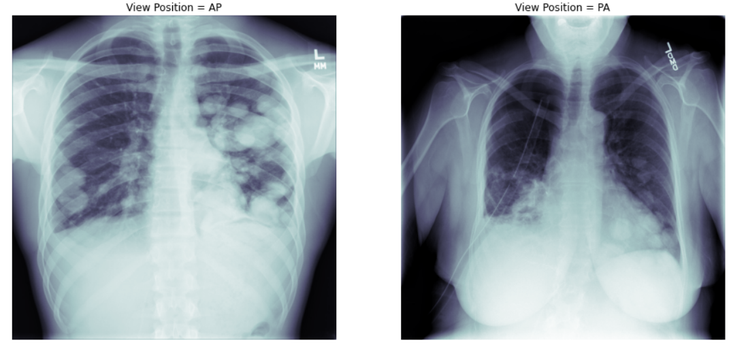

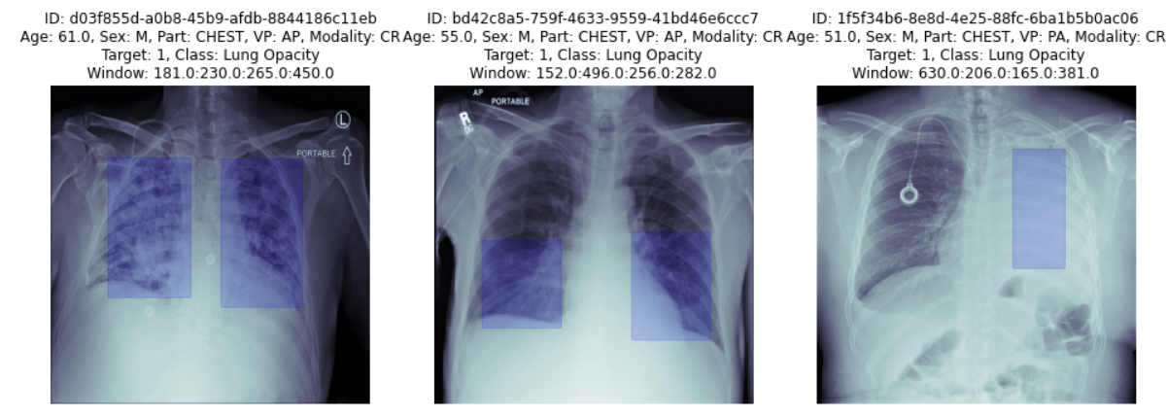

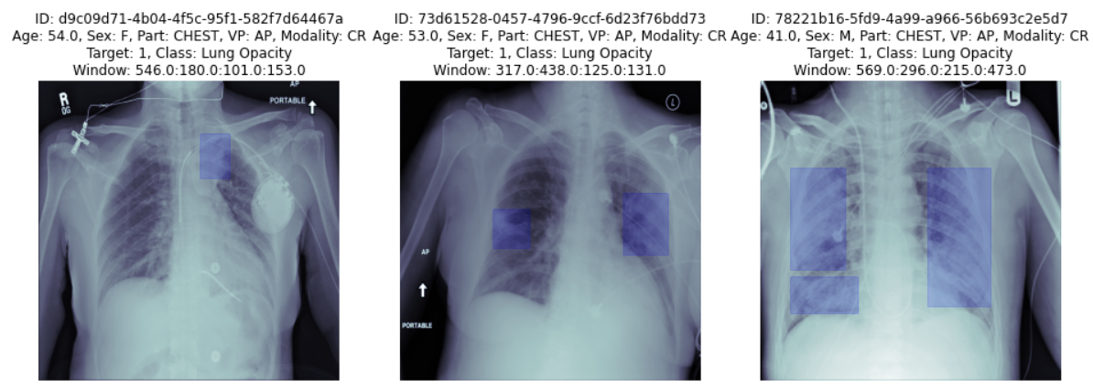

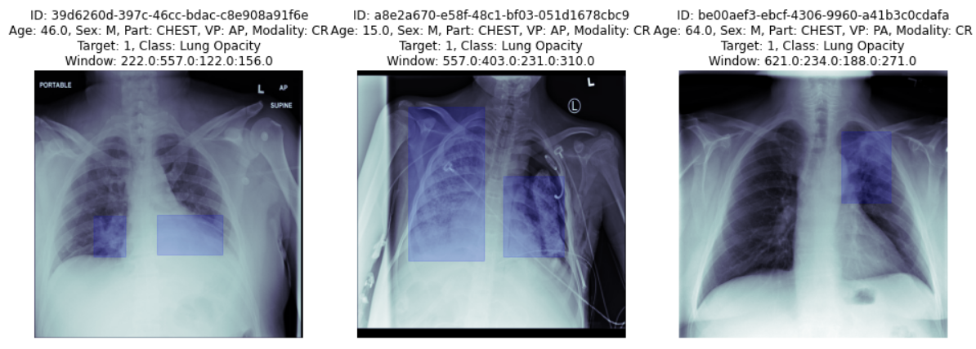

# Modeling

***Deciding Models and Model Building Based on the nature of the problem, decide what algorithms will be suitable and why? Experiment with different algorithms and get the performance of each algorithm.***

Yolo( You Only Look Once) is fastest among other object detection algorithms. Along with speed it also provides good accuracy for even very smaller objects. It performs both classification and bounding box regression at the same time. As it has a simple architecture it runs a lot faster than Faster RCNN. It is very good choice for real time applications.

The performance has been shown in the Jupiter notebook.

### Model Approach -1

#### 1. Deciding on the model selection and reasoning

A: As per the problem statement analyzed, explored and inferred upon, the observation was that the problem to solve in hand was of object detection and object localization. Inference from the EDA process was that x-ray scans can have multiple instances of pneumonia detection, so it is kind of instance segmentation problem to solve.

The choice was to go with Mask R-CNN neural network model. As this model is suited for problems for class labels, bounding box offset and also outputs the object mask which is an addition to FasterRCNN model.

MasRCNN is simple to train, faster and also gives flexibility for class recognition.

As part of the solution to the given problem statement, the matterplot library was used for the Mask R-CNN implementation.

https://github.com/matterport/Mask_RCNN

#### 2. Performance and data set used for the model

As stated above, Mask R-CNN has been utilized to prepare a model for the object detection, localization and masking. For training and testing the model built with the configuration, a small data set was used from the train images set. The data set was divided into a train and a validation set in ration of 1:5

Following is the approach taken to train the model

1. Mask R-CNN model was loaded with pre-trained weights from MS COCO, which is trained to segment objects in the images.
2. Tensoflow v1 and other dependencies were sorted out to make the MASK R-CNN model get loaded with the defined configurations
3. Before preparing the model, certain configuration parameters need to be set like non-maximum suppression (NMS), intersection over union (IoU), image size, number of ROIs per image, ROI pooling layer, number of class, backbone network etc

Below shows what configuration was used to load the model

Configurations:

BACKBONE                       resnet50

BACKBONE_STRIDES               [4, 8, 16, 32, 64]

BATCH_SIZE                     8

BBOX_STD_DEV                   [0.1 0.1 0.2 0.2]

COMPUTE_BACKBONE_SHAPE         None

DETECTION_MAX_INSTANCES        3

DETECTION_MIN_CONFIDENCE       0.7

DETECTION_NMS_THRESHOLD        0.1

FPN_CLASSIF_FC_LAYERS_SIZE     1024

GPU_COUNT                      1

GRADIENT_CLIP_NORM             5.0

IMAGES_PER_GPU                 8

IMAGE_CHANNEL_COUNT            3

IMAGE_MAX_DIM                  256

IMAGE_META_SIZE                14

IMAGE_MIN_DIM                  256

IMAGE_MIN_SCALE                0

IMAGE_RESIZE_MODE              square

IMAGE_SHAPE                    [256 256   3]

LEARNING_MOMENTUM              0.9

LEARNING_RATE                  0.001

LOSS_WEIGHTS                   {'rpn_class_loss': 1.0, 'rpn_bbox_loss': 1.0, 'mrcnn_class_loss': 1.0, 'mrcnn_bbox_loss': 1.0, 'mrcnn_mask_loss': 1.0}

MASK_POOL_SIZE                 14

MASK_SHAPE                     [28, 28]

MAX_GT_INSTANCES               3

MEAN_PIXEL                     [123.7 116.8 103.9]

MINI_MASK_SHAPE                (56, 56)

NAME                           pneumonia

NUM_CLASSES                    2

POOL_SIZE                      7

POST_NMS_ROIS_INFERENCE        1000

POST_NMS_ROIS_TRAINING         2000

PRE_NMS_LIMIT                  6000

ROI_POSITIVE_RATIO             0.33

RPN_ANCHOR_RATIOS              [0.5, 1, 2]

RPN_ANCHOR_SCALES              (8, 16, 32, 1, 1)

RPN_ANCHOR_STRIDE              1

RPN_BBOX_STD_DEV               [0.1 0.1 0.2 0.2]

RPN_NMS_THRESHOLD              0.7

RPN_TRAIN_ANCHORS_PER_IMAGE    256

STEPS_PER_EPOCH                10

TOP_DOWN_PYRAMID_SIZE          256

TRAIN_BN                       False

TRAIN_ROIS_PER_IMAGE           32

USE_MINI_MASK                  True

USE_RPN_ROIS                   True

VALIDATION_STEPS               50

WEIGHT_DECAY                   0.0001

1. Model architecture is built - Constructor of the model accepts 3 params i.e. mode, config and path

The model was loaded in “training” mode with the above config and a path defined where the logs and the weights of the model will be saved.Also the model is training the head layers only, as the model contain enormous layers and training them would take extensive time.

1. Dataset is prepared for training and validation, resizing and parameter  are set which would be accepted by the model
2. The model is initially executed with 4 epochs and steps per epoch as 10
3. Post execution, the performance of the model is shown as below -

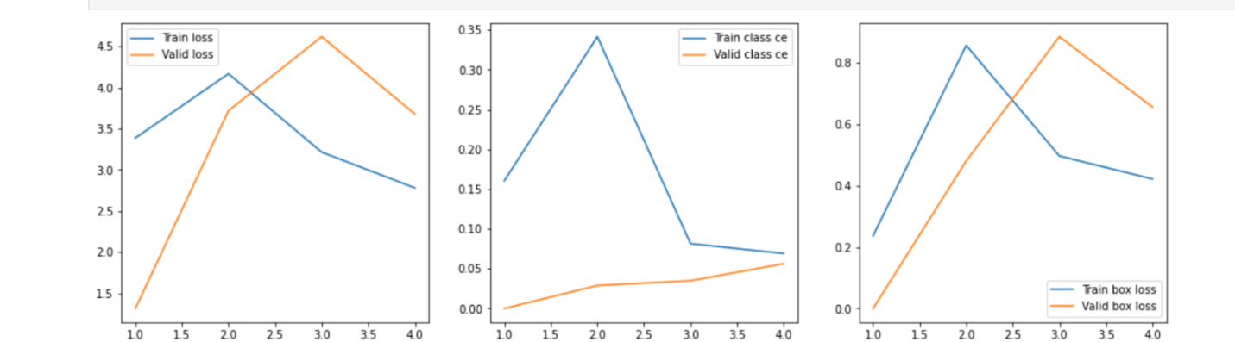

As seen from the above diagram, the model loss on train and validation data has reduced with each epoch, but also it is not ideal as the loss is too high and some hyper tuning and parameters for the model need to be updated.

1. Some sample images are passed to the model for object detection and the result is as below

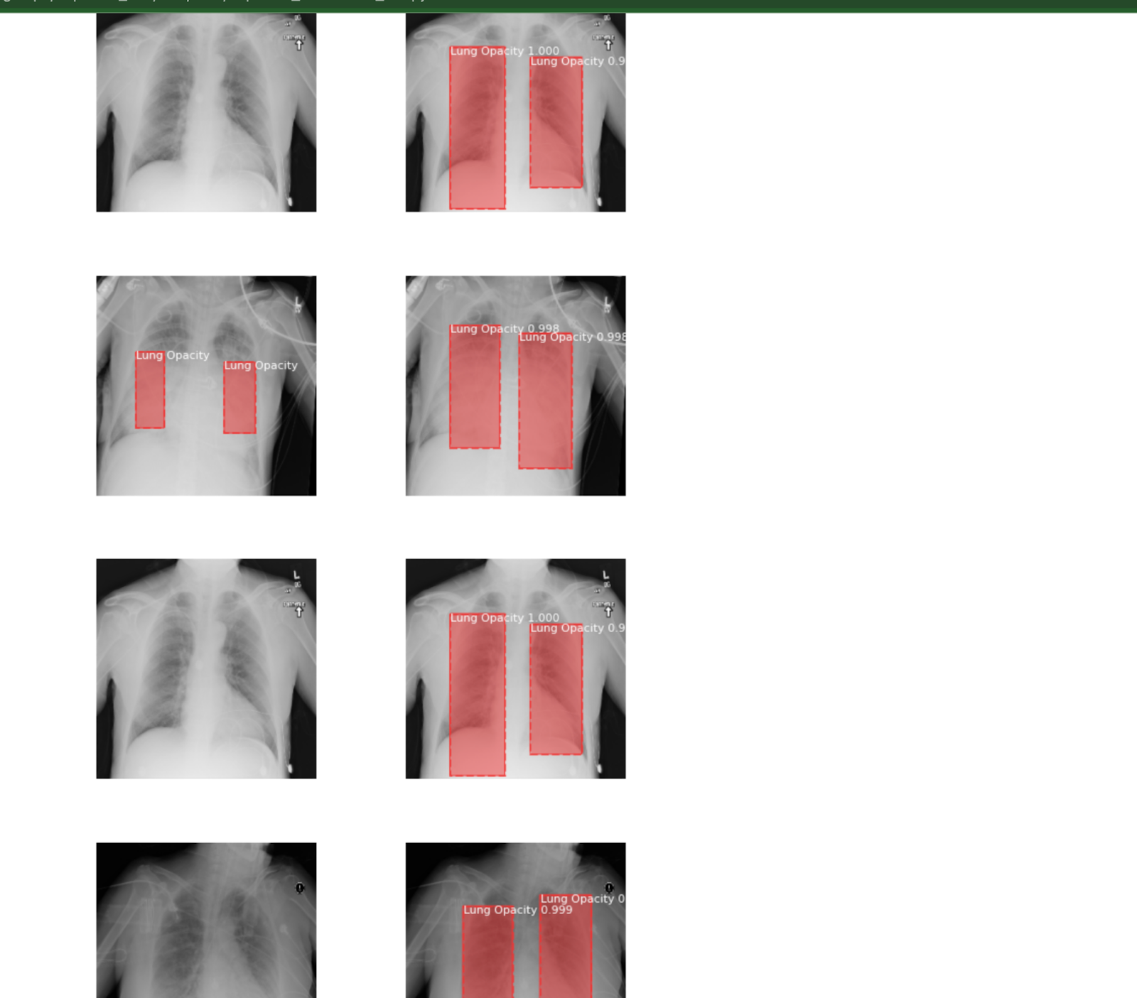

As seen from the above sample, the objects are in correctly detected for some of the images, and for one image multiple bounding boxes are shown (image 2) , but the area of detection is larger than what should be expected.

This clearly states the model is still not correctly trained and a larger data set needs to be fed into the model as well the model need to be hyper tunned.

#### 3. Tuning the model

As part of the tuning and increase the model performance, data set for training has to be increased in size. Also along with that parameters such as IOU, learning rate, weights learned in transfer learning , steps to be trained and frozen all these need to be re-looked and hyper tunned to get better performance out of the model.

# Model Testing

## Mask R-CNN

As per the problem statement analyzed, explored and inferred upon, the observation was that the problem to solve in hand was of object detection and object localization. Inference from the EDA process was that x-ray scans can have multiple instances of pneumonia detection, so it is kind of instance segmentation problem to solve.

The choice was to go with Mask R-CNN neural network model. As this model is suited for problems for class labels, bounding box offset and outputs the object mask which is an addition to Faster RCNN model.

Mask R-CNN is simple to train, faster and also gives flexibility for class recognition.

**The Mask R-CNN model predicts the class label, bounding box, and mask for the objects in an image. Here is an example of what the model could detect.**

As part of the solution to the given problem statement, the matterplot library was used for the Mask R-CNN implementation.

<https://github.com/matterport/Mask_RCNN>

### Architecture of Mask R-CNN

Mask R-CNN is one of the recent additions to Region Based CNN Family, which was launched by Kaiming He and team from Facebook AI Research (FAIR) in January of 2018

Mask R-CNN is an extension of Faster R-CNN which creates the mask at pixel level for each object detected

Along with this enhanced performance, Mask R-CNN involves several hyper parameters which are to be tuned carefully based on the application.

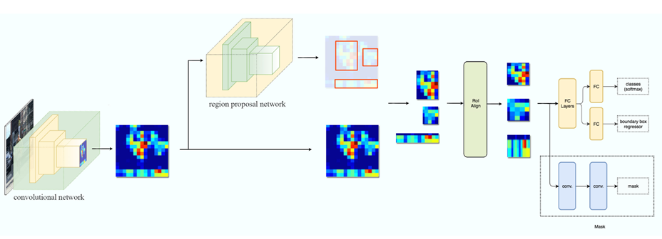

*Mask R-CNN Architecture*

The block diagram above represents the Mask R-CNN architecture. A brief description of each of the steps is given below:

. The image is passed through a convolutional network.

. The output of first conv net, is passed through to a Region Proposal network (RPN) which creates different achor boxes (Regions of Interest) based on the presence of any of the objects to be detected.

. The Anchor boxes are sent to ROI Align stage (one of the key features of Mask R-CNN for protecting spatial orientation), which converts ROI’s to the same size required for further processing

. This output is sent to Fully connected layers which will generate the result of the class of the object in that specific region and the location of the bounding box for the object

. The output of ROI Align stage is parallelly sent to Conv Nets in order to generate a mask of the pixels of the object

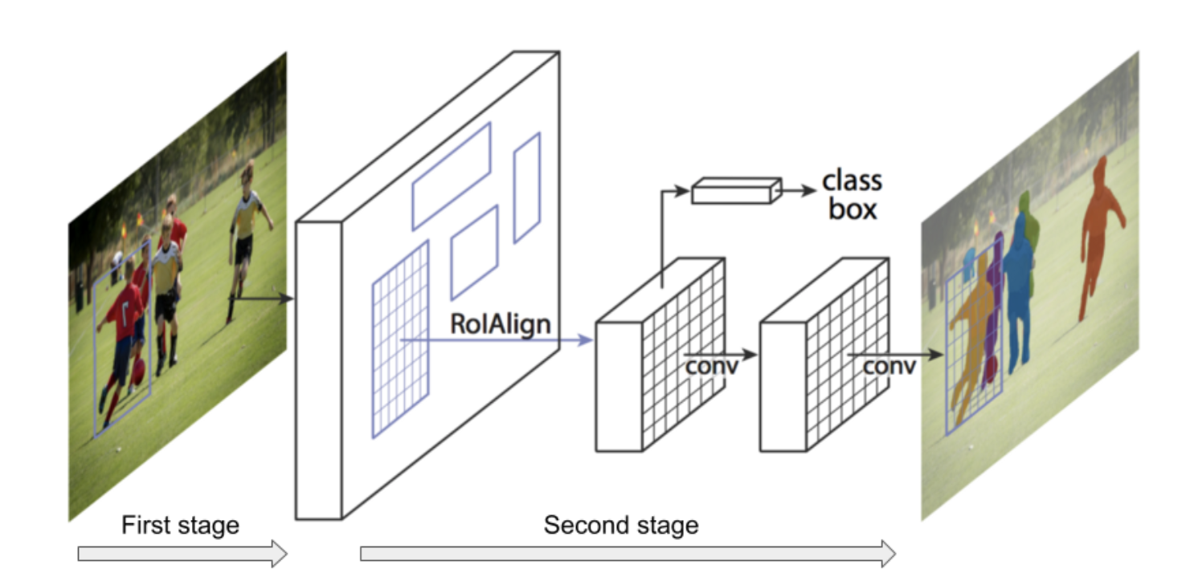

MaskRCNN in a nutshell explained above

### Problem Solving

The approach for the problem solving has following phases:

1. EDA and Data preprocessing
2. Model building and comparison between various models chosen
3. Hypertune the model
4. Evaluate the performance on validation dataset
5. Run the model on test data set and evaluate the performance
6. Deploying the model as a service, taking image as input and outputting the response with class and bounding box.

#### EDA and Data preprocessing

EDA and data processing is explained in the previous steps, in terms of preparing the data for input for usage in this model i.e resizing and scaling are explained in the model b building process

#### Model building and comparison between various models chosen

Mask R-CNN matterport open source project was chosen to build the model upon. The Mask R-CNN model predicts the class label, bounding box, and mask for the objects in an image.

The project has 4 directories -

mrcnn: This is the core directory that holds the project's Python code. samples: Jupyter notebooks providing some examples to use the project. images: A collection of test images.

assets: Some annotated images.

The most important directory is mrcnn, as it holds the source code for the project.

It has the following Python files:

__init__.py: Marks the mrcnn folder as a Python library.

model.py: Has the functions and classes for building the layers and the model.

config.py: Holds a class named Config that holds some configuration parameters about the model.

utils.py: Includes some helper functions and classes.

visualize.py: Visualizes the results of the model.

parallel_model.py: For supporting multiple GPUs.

Steps used to detect the object using Mask R-CNN are as below -

The steps to use the Mask_RCNN project to detect objects in an image are:

* Prepare the model configuration parameters.
* Build the Mask R-CNN model architecture.
* Load the model weights.
* Read an input image.
* Detect objects in the image.
* Visualise the results.

#### Prepare the model configuration parameters.

There are multiple configurations for the model params which can be utilized for hyper parameterization, some examples are -

##### Back Bone:

The Backbone is the Conv Net architecture that is to be used in the first step of Mask R-CNN. The conv net chosen was **resnet50**, it is faster to train it and can be used with a loaded weight.

##### Train_ROIs_Per_Image:

This is the maximum number of ROI’s, the Region Proposal Network will generate for the image, which will further be processed for classification and masking in the next stage.

##### Max_GT_Instances:

This is the maximum number of instances that can be detected in one image.

##### Detection_Min_Confidence:

This is the confidence level threshold, beyond which the classification of an instance will happen.

##### Image_Min_Dim and Image_Max_Dim:

The image size is controlled by these settings. The default settings resize images to squares of size 1024x1024. The image size chosen was 256 by 256.

**Loss weights:** Rpn_class_loss, Rpn_bbox_loss, Mrcnn_class_loss, Mrcnn_bbox_loss, Mrcnn_mask_loss

The final parameters on which the model was trained and then hyper tuned later are as below -

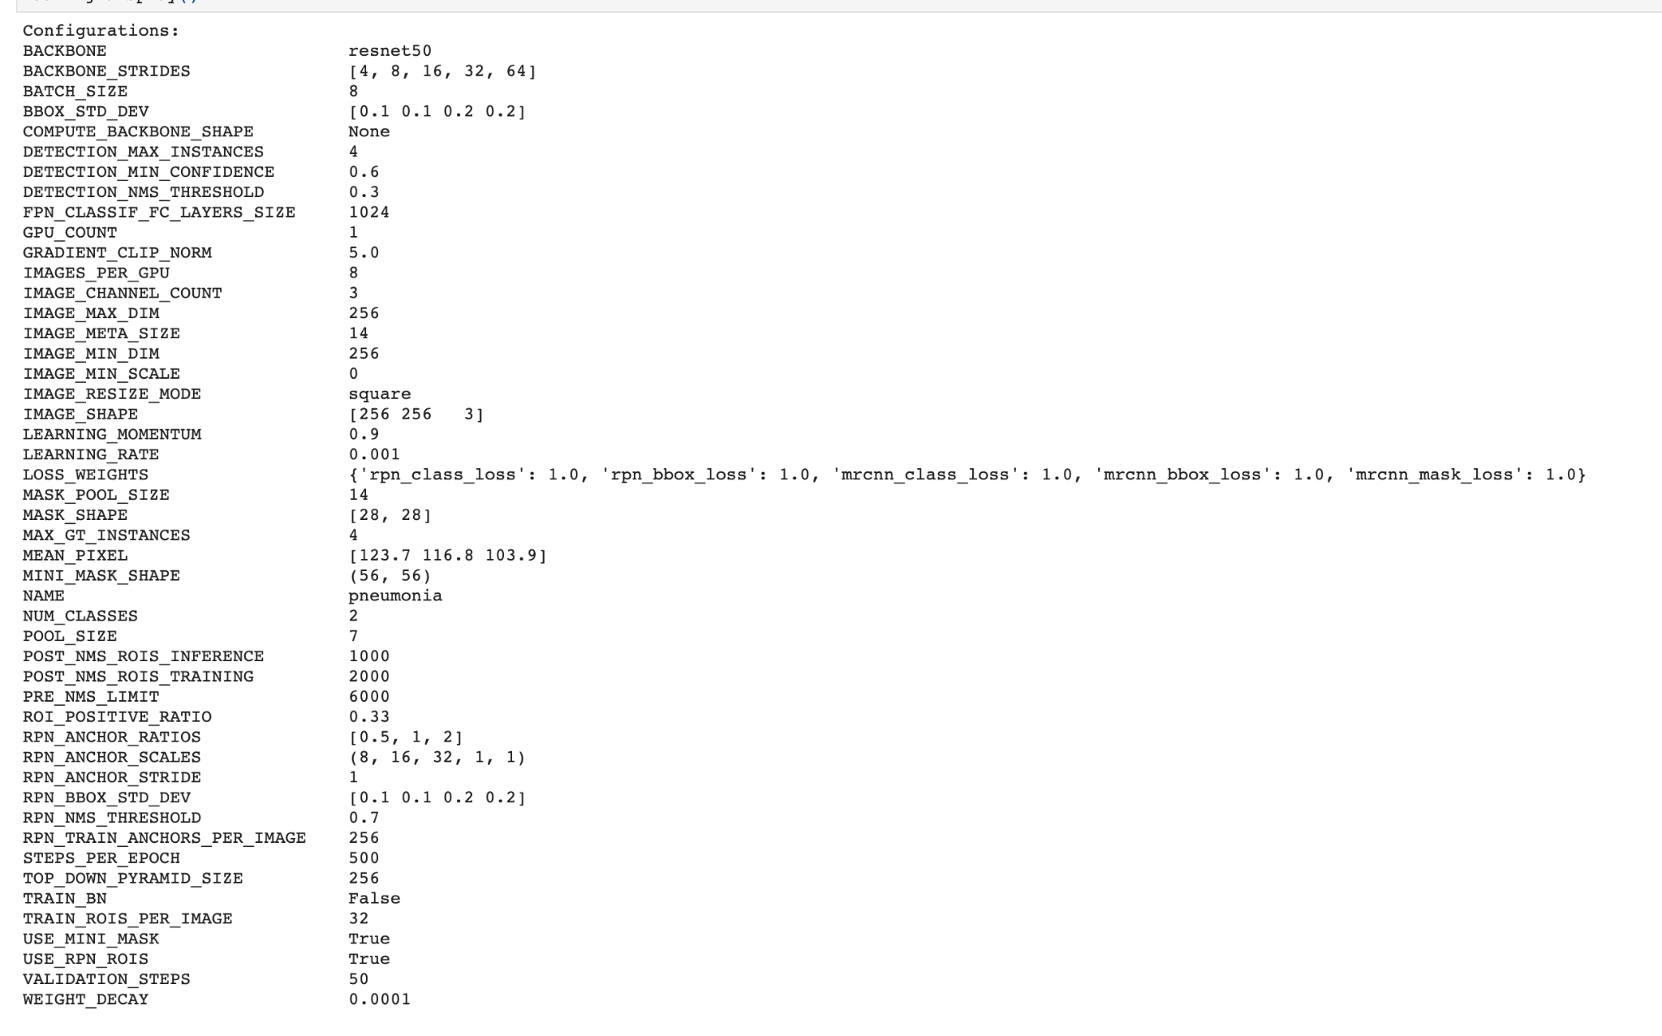

#### Build the Mask R-CNN model architecture

The model is built initially in training mode and the best epoch trained weights are loaded for the model for evaluation in the inference mode.

While training pre-trained weights are loaded, in the current project pre-trained MS COCO dataset weights.

As the model architecture has lot of layers and to train them all will be too time consuming and with using pretrained weights the model is trained only for the head layers.

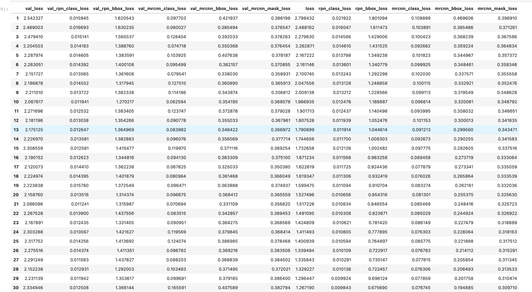

As seen with the above results, it seemed that the 10th epoch was the best performing one and the weights for the same were taken and loaded for the model in inference mode.

With those weights the model is then loaded in an inference model and evaluation is done upon it.

##### Detecting objects in validate/train set

On the best performing epoch, the weights are loaded into the model with inference mode. The model is then used to evaluate images passed into it which then output the bounding box, confidence and the mask.

The below plots show

1. Train loss and validation loss vs each epoch

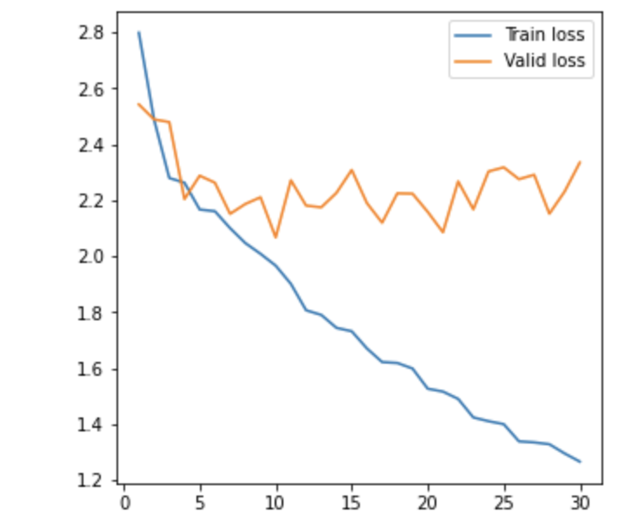

1. Training class loss and validation class loss for each epoch

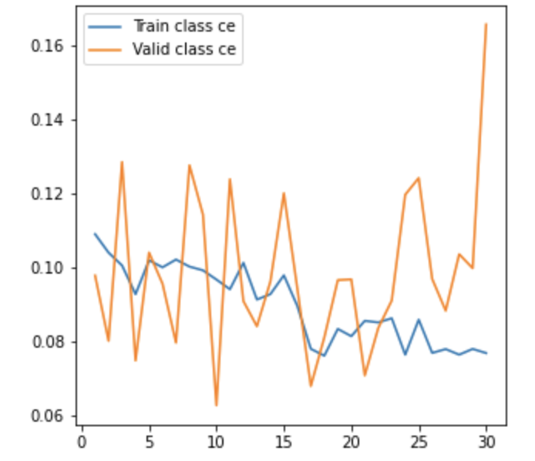

1. The train and validation bounding box loss vs the number of epochs.

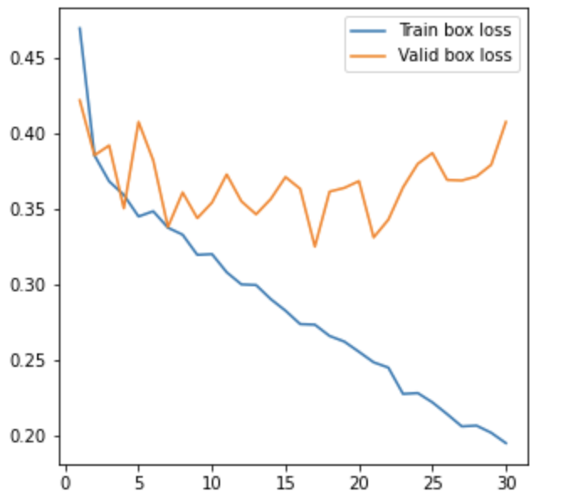

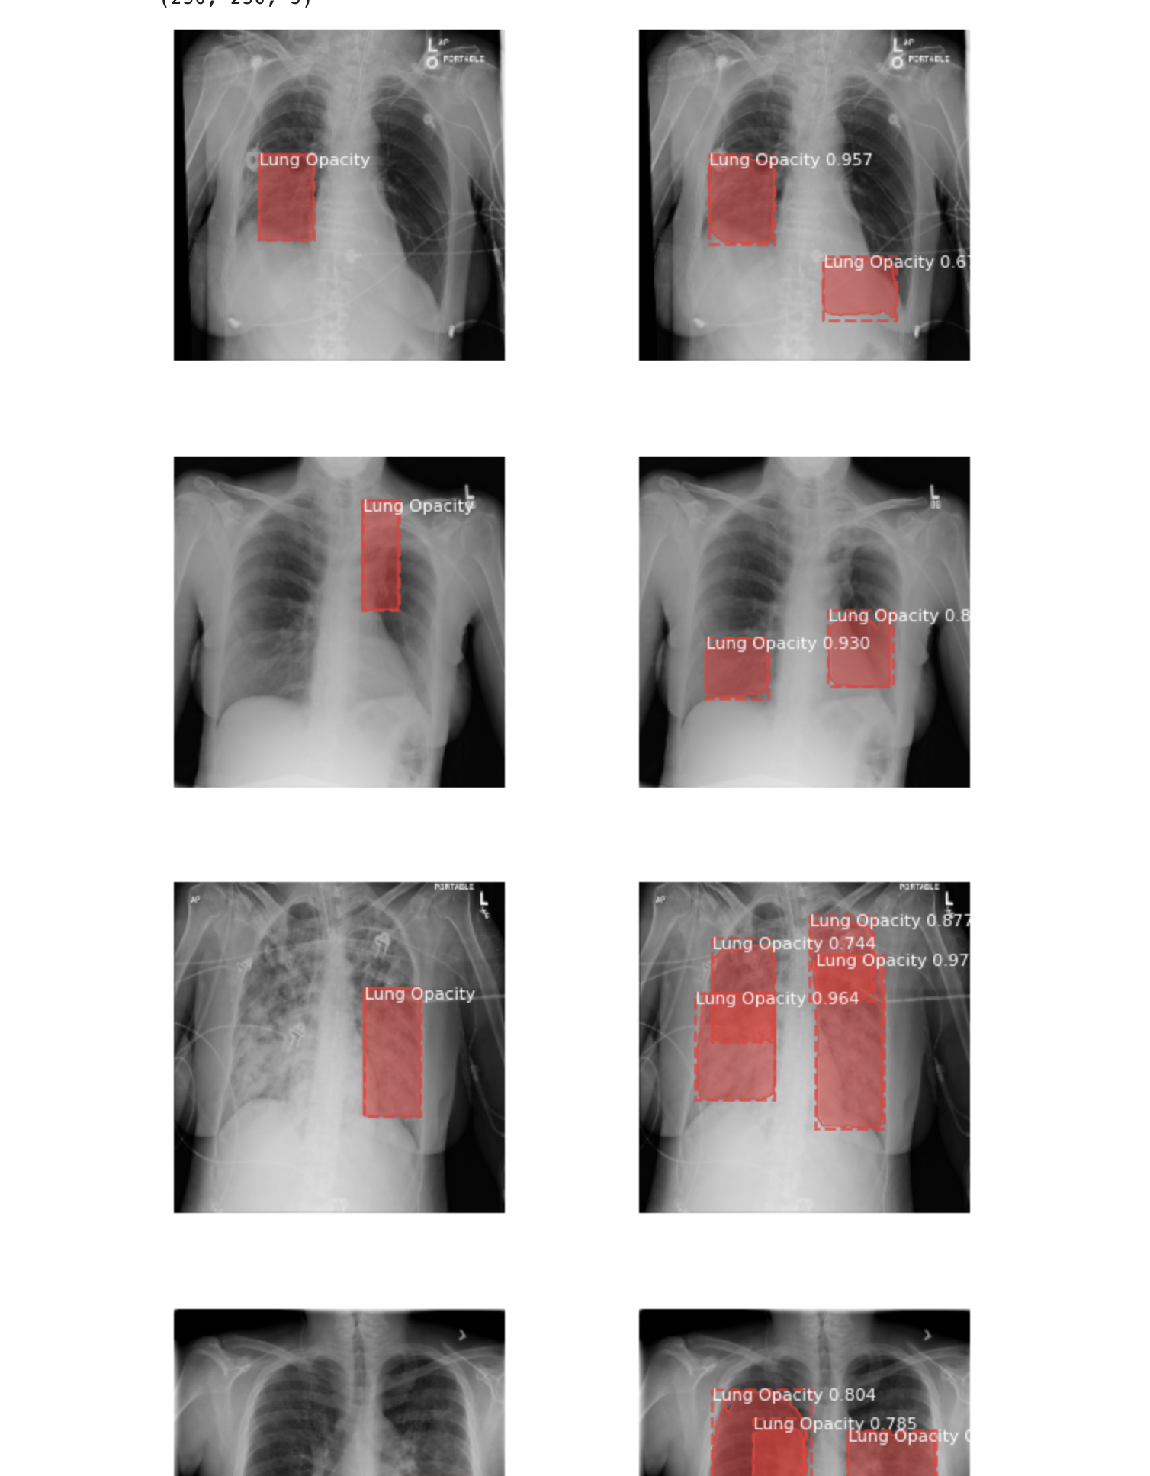

As seen with the above images, on left being the actual ground truth and on the right being the plotting done by the model.

For images having gone instance of the infection, they are plotted correctly y the model with few FP (false positives)

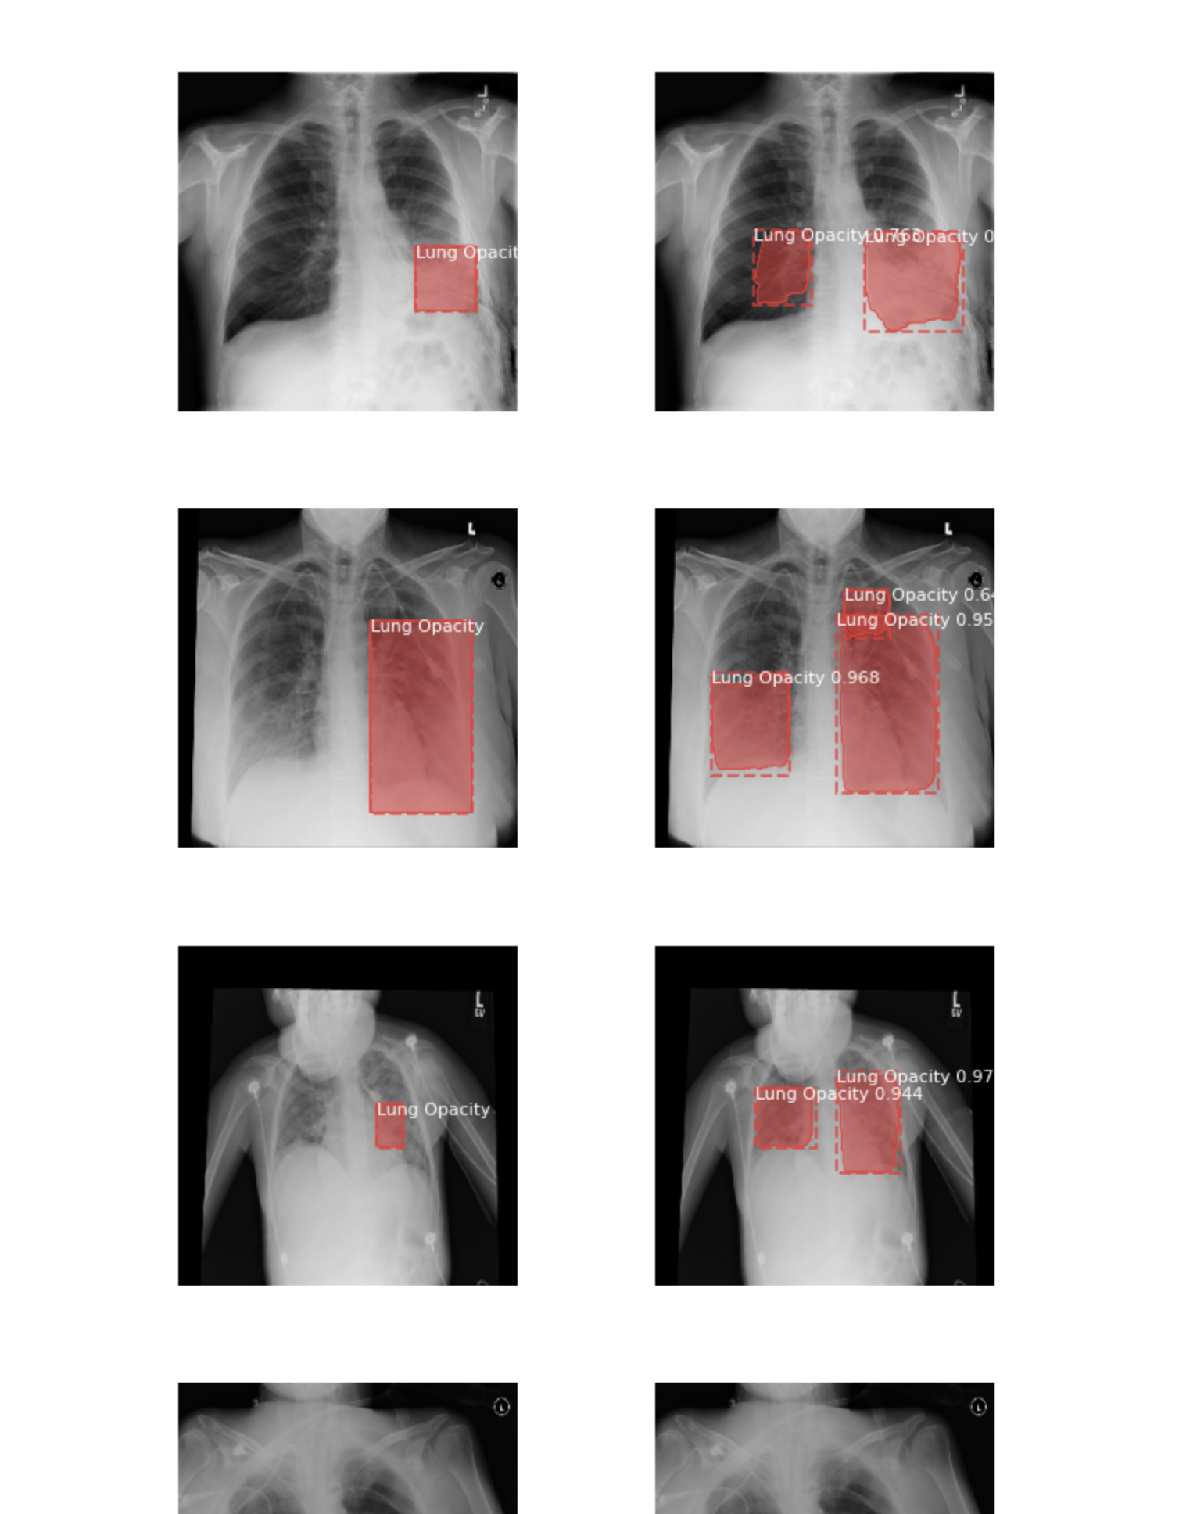

Above images show a similar trend of the bounding box getting plotted correctly around the infection as shown in the ground truth image.

##### Summary:-

**Understanding IOU for the images and the mean Average precision for it**

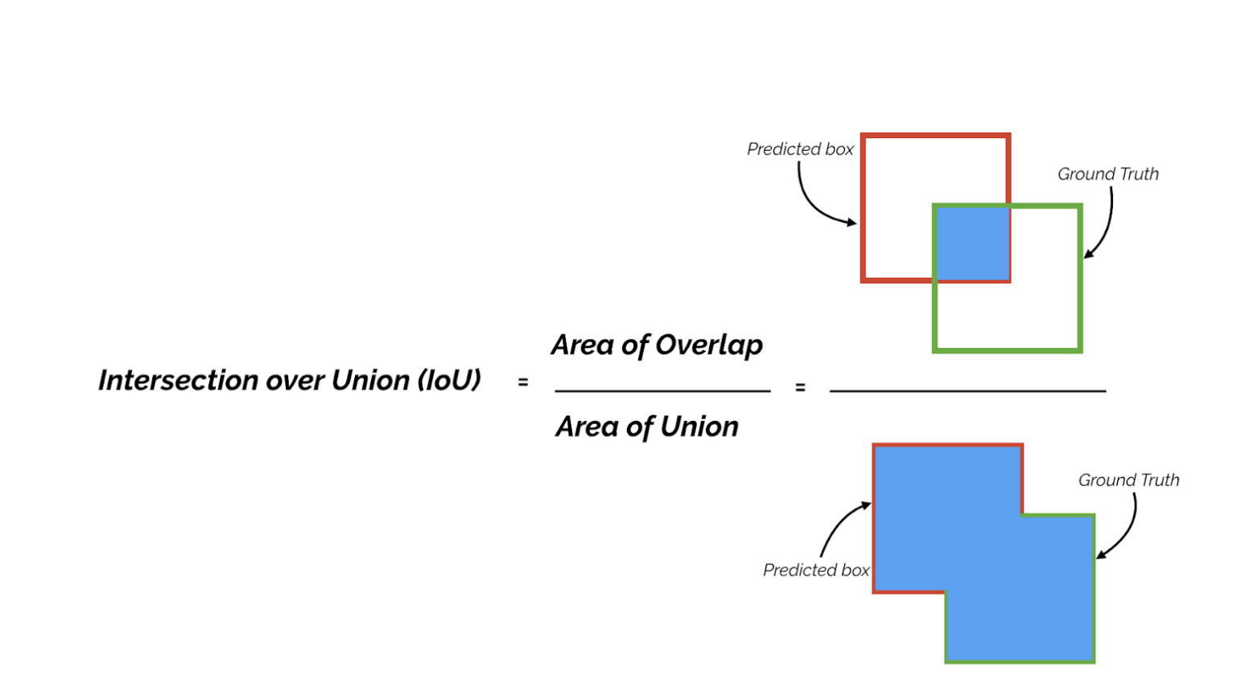

**For example, if IoU threshold is 0.5, and the IoU value for a prediction is 0.7, then we classify the prediction as True Positive (TF). On the other hand, if IoU is 0.3, we classify it as False Positive (FP)**

**The stats for the model execution :-**

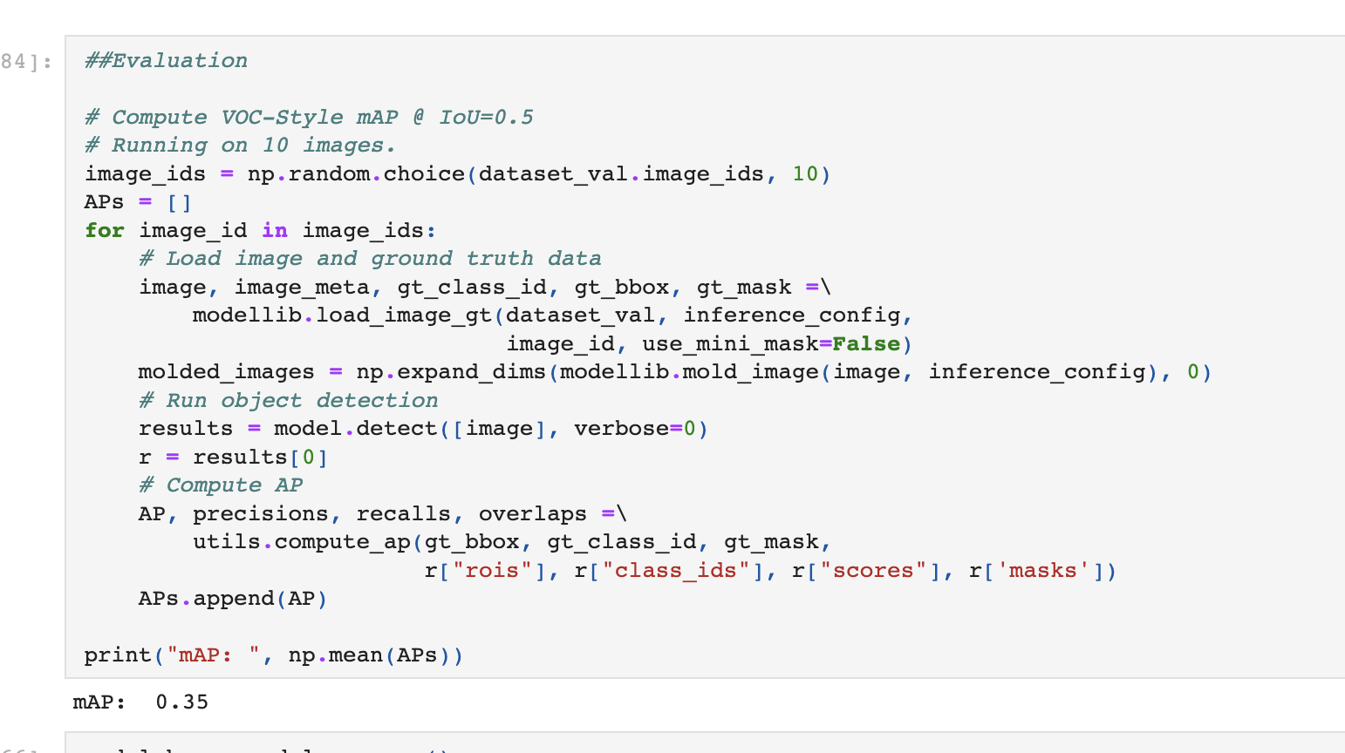

**The mean Average precision is 0.3 and as seen with the plotting of images with ground truth and the actual model performing the bounding boxes, we can see there are infact few False positives seen.**

**As we understand with the case study, with a medical case like the one shared, a patient coming in and getting analyzed for false positive is far better scenario than patient coming in and having a false negative and being turned away. So in terms and context of this case study and domain of the problem, the model has been performing well and able to successfully detect the infection region(s) (multiple in one image) successfully.**

## YOLOv5

### What is YOLOv5

YOLO an acronym for 'You only look once', is an object detection algorithm that divides images into a grid system. Each cell in the grid is responsible for detecting objects within itself.

YOLO is one of the most famous object detection algorithms due to its speed and accuracy.

Source - <https://docs.ultralytics.com/>

YOLO stands for You Look Only Once and it is one of the finest family of object detection models with state-of-the-art performances.

Its first model was released in 2016 by Joseph Redmon who went on to publish YOLOv2 (2017) and YOLOv3 (2018). In 2020 Joseph Redmon stepped out from the project citing ethical issues in the computer vision field and his work was further improved by Alexey Bochkovskiy who produced YOLOv4 in 2020.

YOLOv5 is the next controversial member of the YOLO family released in 2020 by the company Ultranytics just a few days after YOLOv4.

Source - <https://machinelearningknowledge.ai/introduction-to-yolov5-object-detection-with-tutorial/#What_is_YOLOv5>

### YOLOv5 Architecture

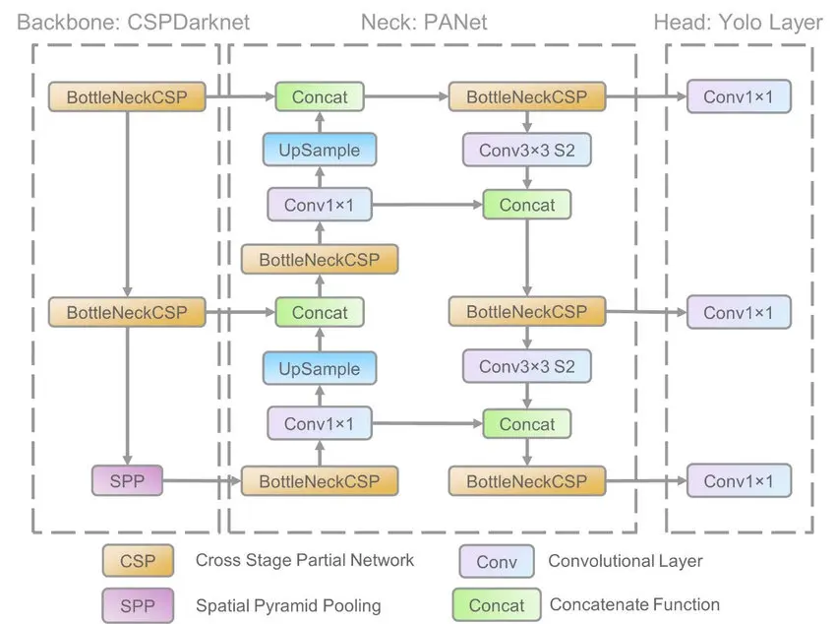

([Source](https://www.researchgate.net/publication/349299852_A_Forest_Fire_Detection_System_Based_on_Ensemble_Learning))

The YOLO family of models consists of three main architectural blocks i) Backbone, ii) Neck and iii) Head.

1. **YOLOv5 Backbone:** It employs CSPDarknet as the backbone for feature extraction from images consisting of cross-stage partial networks.
2. **YOLOv5 Neck:** It uses PANet to generate a feature pyramids network to perform aggregation on the features and pass it to Head for prediction.
3. **YOLOv5 Head:**  Layers that generate predictions from the anchor boxes for object detection.

Apart from this YOLOv5 uses the below choices for training –

1. **Activation and Optimization:** YOLOv5 uses leaky ReLU and sigmoid activation, and SGD and ADAM as optimizer options.
2. **Loss Function:** It uses Binary cross-entropy with logits loss.

### Why Yolov5-

**Yolo( You Only Look Once)** is fastest among other object detection algorithms.

Along with speed it also provides good accuracy for even very smaller objects.

It performs both classification and bounding box regression at the same time.

As it has a simple architecture it runs a lot faster than Faster RCNN. It is very good choice for real time applications.

### Bounding box in Yolov5 format :

One row per object.

Each row is -class x_center y_center width height.

Box coordinates must be normalized by the dimensions of the image (i.e. have values between 0 and 1)

Class numbers are zero-indexed (start from 0).

Step3- The preprocessed images has been saved in the drive so that we do not need to repeat these steps again and we can directly use the modified dataset.

### Training and Results:

#### Taking 1000 images and learning rate as 0.02

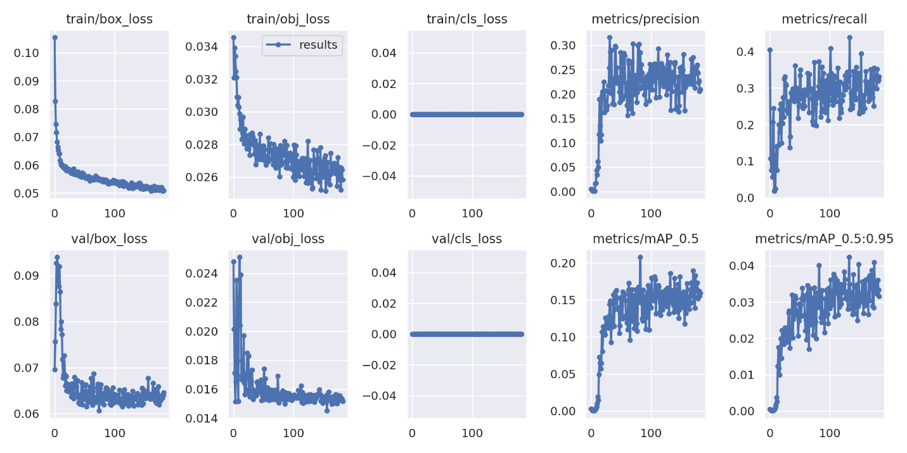

#### Plotting actual bounding boxes and predicted bounding boxes:

**Red** boxes represent actual bounding box.

**Blue** boxes represent predicted bounding box.

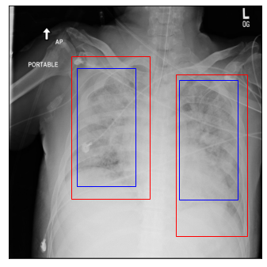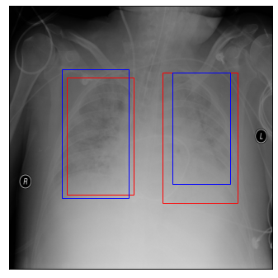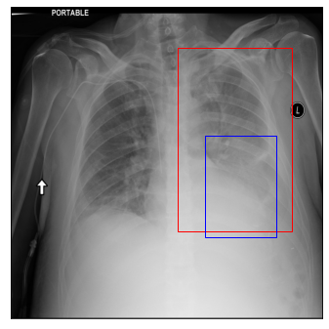

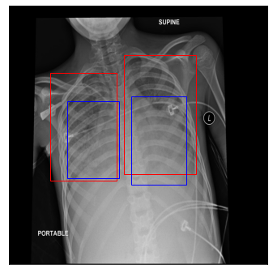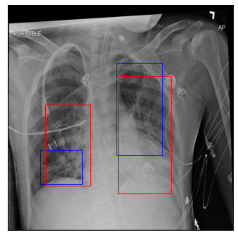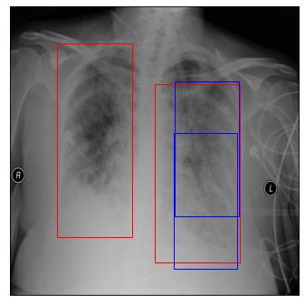

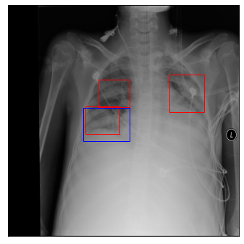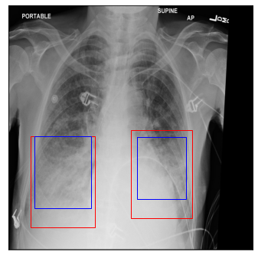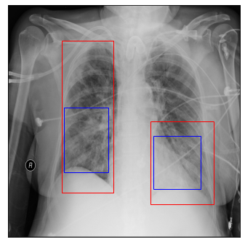

#### Taking full dataset and learning rate as 0.02

In [ ]:

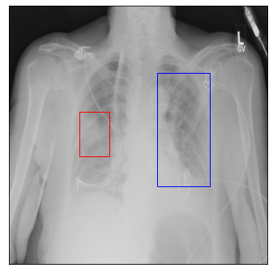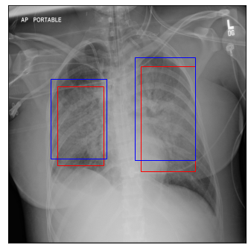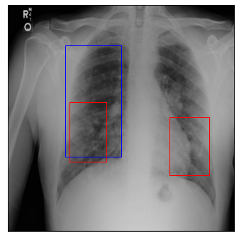

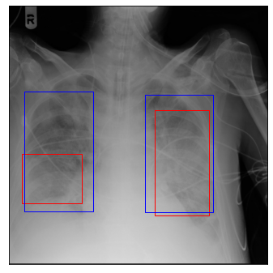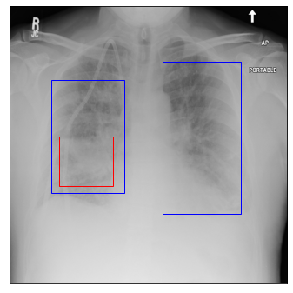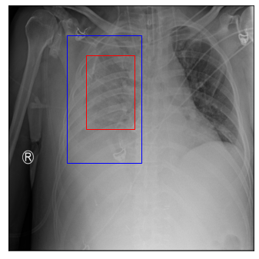

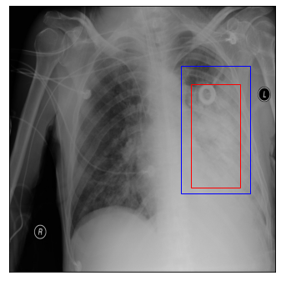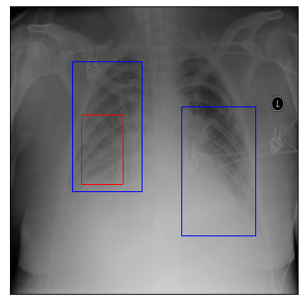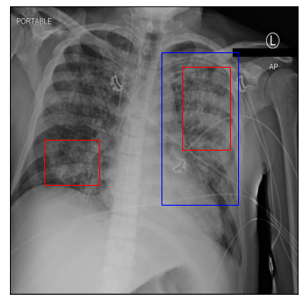

IOU has improved a little by taking more training data

### FINAL BEST MODEL(With hyperparameter tuning)

Learning rate and IOU threshold has been reduced which has improved the results (Hyperparameters are written after results)

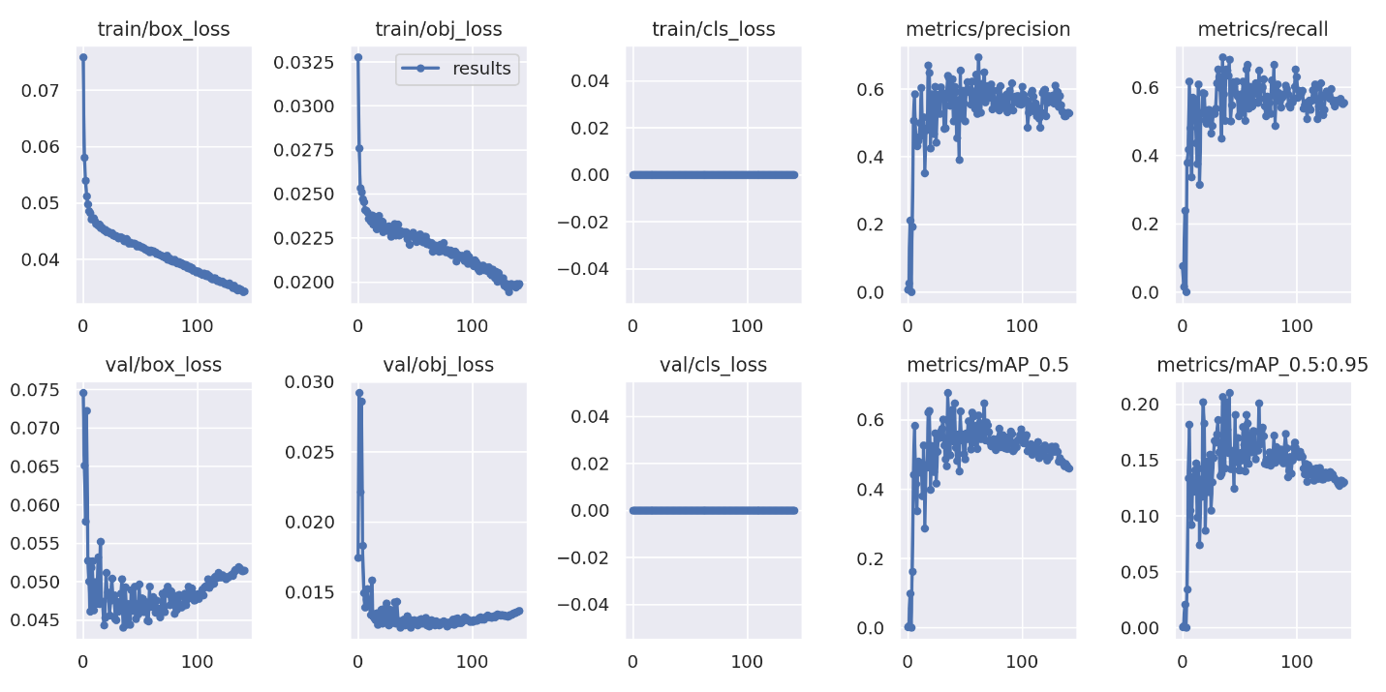

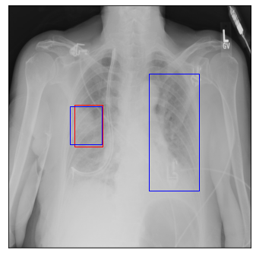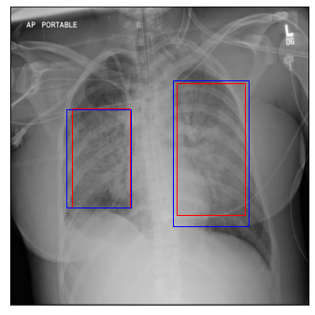

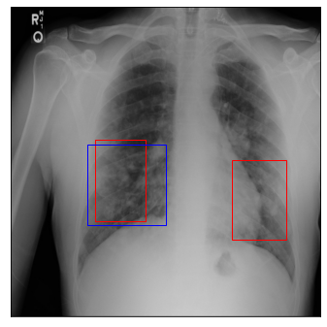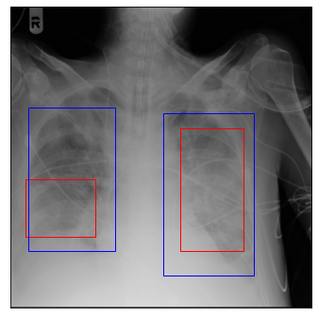

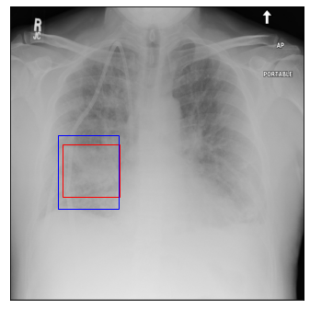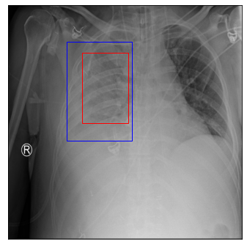

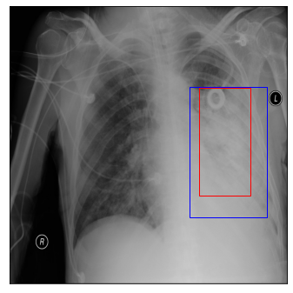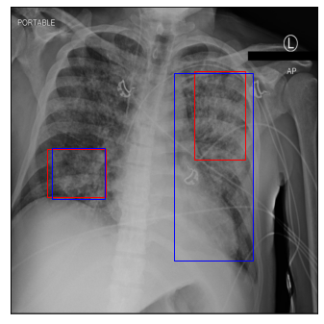

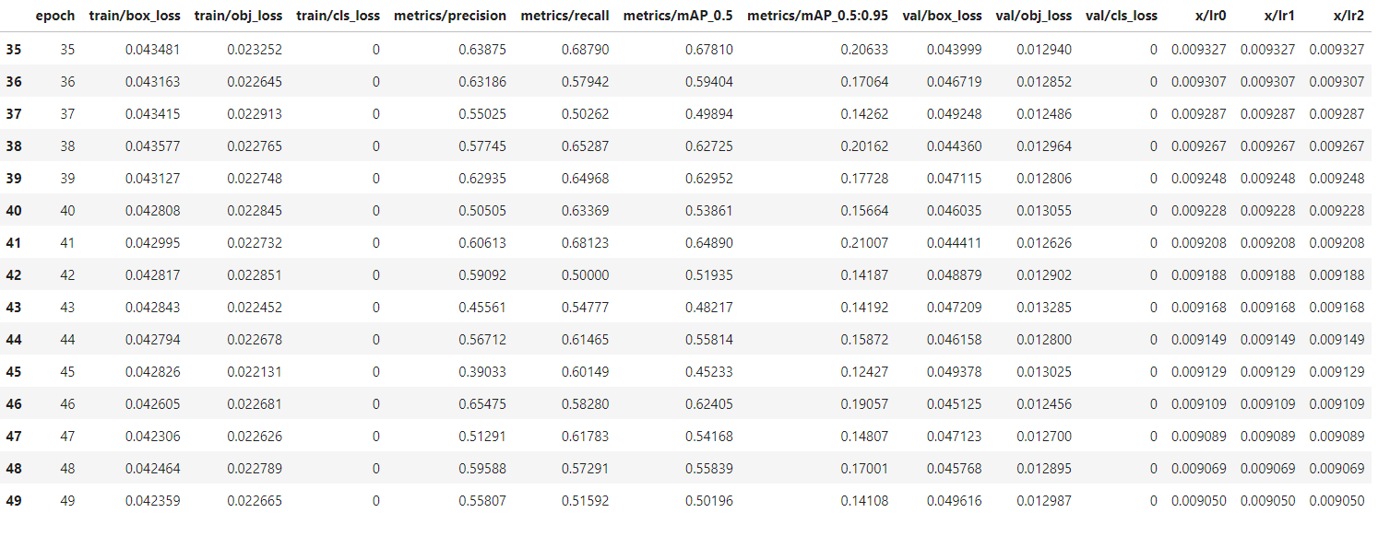

*41 is the best epoch having precision as 0.60 , recall as 0.68 , Map_0.5 is 0.648 and box loss as 0.044.*

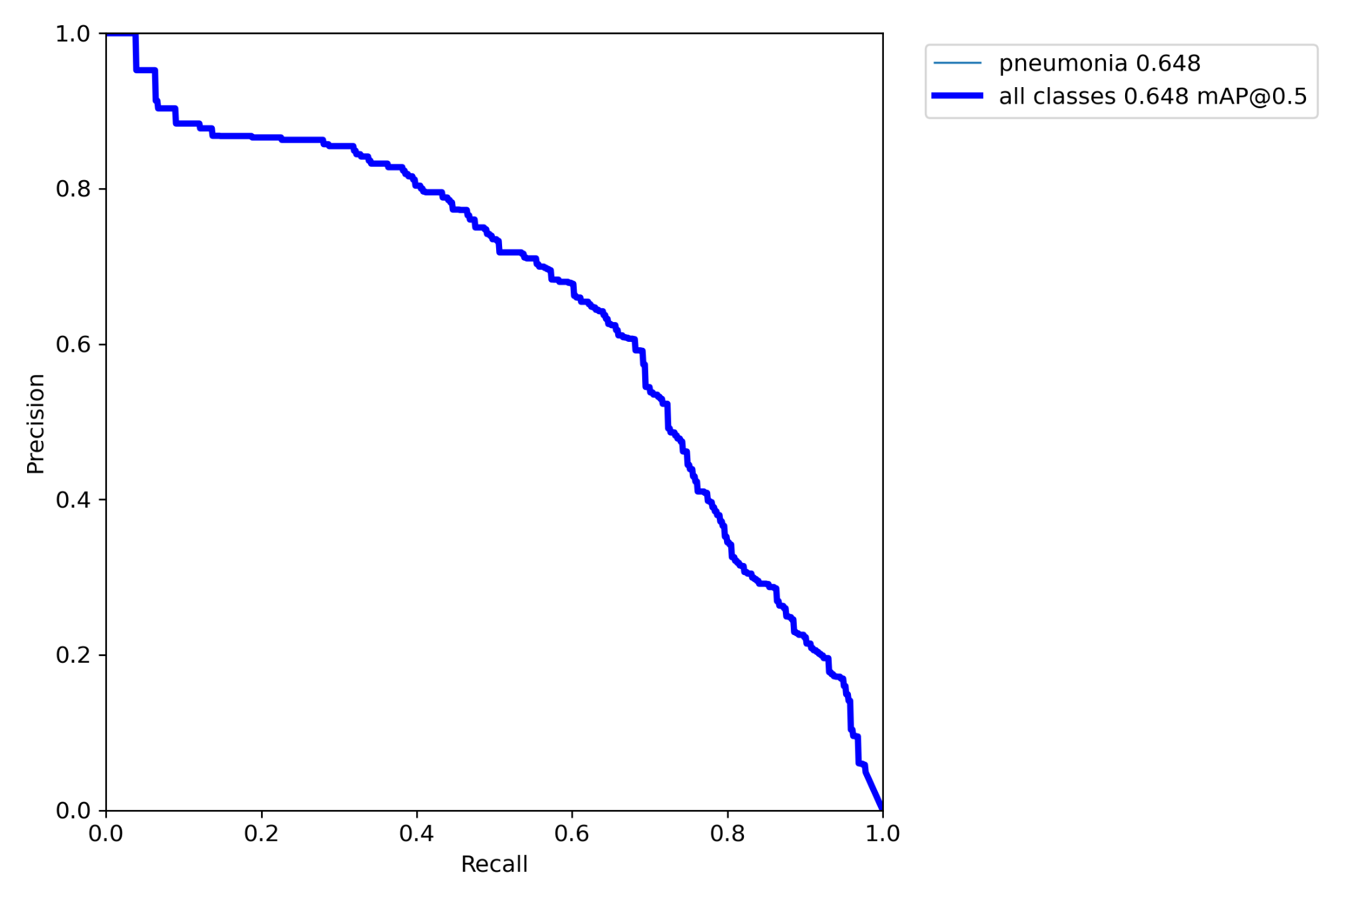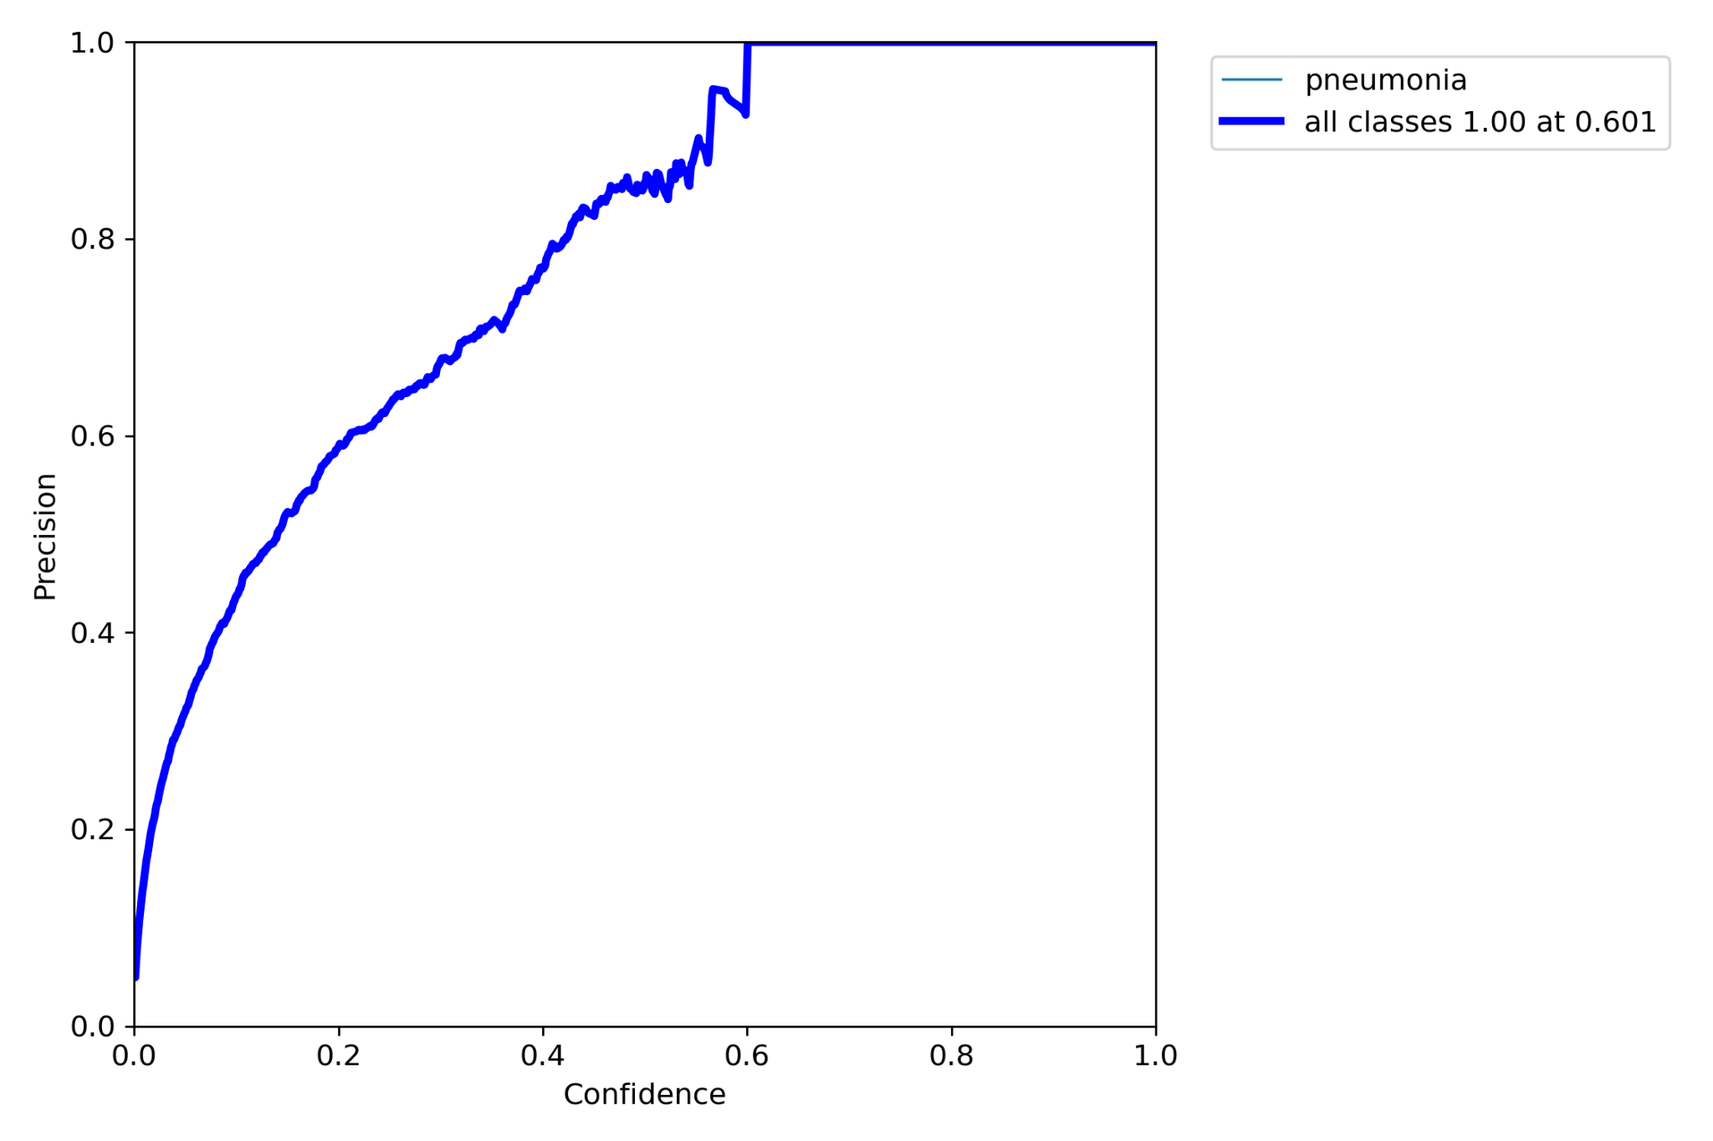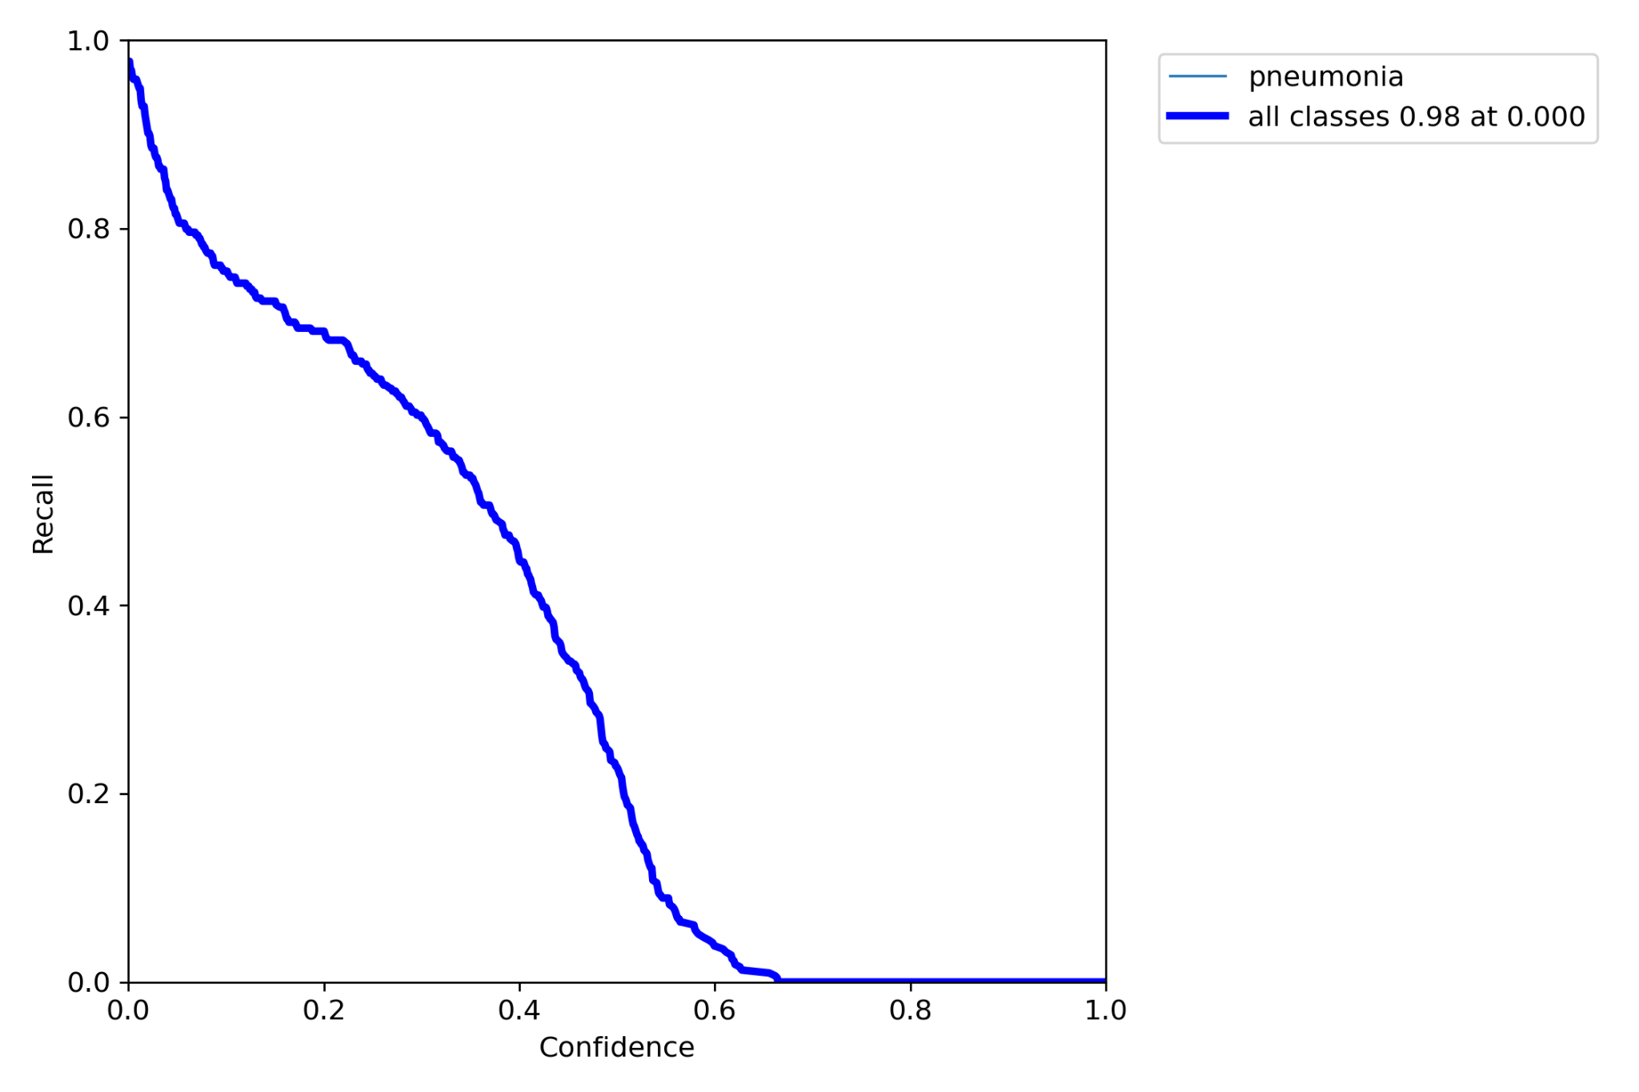

*mAP@0.5 is 0.648*

*Precision is increasing with confidence*

*Recall is decreasing with confidence*

#### HYPERPARAMETERS:

lr0: 0.01 # initial learning rate (SGD=1E-2, Adam=1E-3)

lrf: 0.2 # final OneCycleLR learning rate (lr0 * lrf) batch_size=64

momentum: 0.937 # SGD momentum/Adam beta1

weight_decay: 0.0005 # optimizer weight decay 5e-4

warmup_epochs: 3.0 # warmup epochs (fractions ok)

warmup_momentum: 0.8 # warmup initial momentum

warmup_bias_lr: 0.1 # warmup initial bias lr

box: 0.05 # box loss gain

cls: 0.5 # cls loss gain

cls_pw: 1.0 # cls BCELoss positive_weight

obj: 1.0 # obj loss gain (scale with pixels)

obj_pw: 1.0 # obj BCELoss positive_weight

iou_t: 0.20 # IoU training threshold

anchor_t: 4.0 # anchor-multiple threshold

# anchors: 3 # anchors per output layer (0 to ignore)

# SUMMARY AND CONCLUSION:

## Data preparation:

Step1- As we have bounding box available for only those patients which are pneumonia positive. So images of only positive patients are taken for training.

Step2- Yolov5 have a specific format of input data. So images has been converted from DICOM to jpg and a text file contained information of class and bounding boxes is generated.

Other preprocessing has also been done.

## Training:

Step1-Firstly the model is trained on only 150 images by using the weights of coco dataset and freezing few initial layers as they are independent of the object.

Model was able to detect nearly 45 % of the bounding boxes.

Step2- Model is trained on 1000 images without freezing any layer. Performance of the model is improved.

Step3- After that by using its previous weight the model is trained on full dataset.

Step4- Then using colab pro + the model is trained from starting with full dataset.

Step5- Tried different combination of hyperparameters and compared performance of the model.

Model performance has been improved by reducing the learning rate and IOU threshold.

The best performing model has been selected.

## Output:

By reducing the learning rate from 0.02 to 0.01 and reducing the IOU threshold from 0.3 to 0.2, performance of the model is improved.

The best performing model is obtained by finetuning yolov5 trained on coco dataset.

Model is capable of detecting 197 patients out of 200 from patients having pneumonia positive.

Only 3 false negatives have been observed out of 200.

Box loss observed is low. Both the actual and predicted bounding boxes are ploted together for comparison and better visualization.

Best Model:

As we can see from above results, both the model have performed well and have been successfully able to achieve the objective of detection of the bounding box for the infection area in x-rays, be it more than one bbox for an xray.

While comparing the performance of the model we can see that Yolo has given a *mAP@0.5 is 0.648.*

*While MaskR-CNN has given a result of mAP@0.5 is 0.35.*

*We see overall both the models have performed well, and there was some overfitting when the models were trained more. Overall Yolo has outperformed Maskrcnn for the given case study, but with more layers being trained and hyper tunning we could see considerable improvement in performance of both the models.*

*To conclude, we can say that the objective of the case study to successfully detect the test images with one oe many bbox has been achieved.*

Learnings:

Understanding the contents of ML datasets is a critical first step to developing suitable strategies to mitigate the impact of unfair dataset bias. Concepts of neural networks, computer vision, transfer learning, early stopping, hyper tunning, evaluating performance of the model etc were learnt during the course of completion of the model creation and execution.

# Appendix

Cutsom Dependencies for model execution:

|  |  |  |
| --- | --- | --- |
| **Dependency** | **Version** | **Source** |
| MaskRCNN | 2.0 | Open source github |
| Tensorflow | 1.x | 1.5 version loaded in colab |
| Keras | 2.16 | Dependency for maskrcnn model |
| H5PY | 2.10.0 | Dependency for maskrcnn model |

Platform used - Colab pro + for execution of the models.

Storage - Google drive was used to upload the train, test set images and the weights for each epoch run were saved in google drive location.

Data source & References- Kaggle, TowardsScience, Medium

Links - <https://blog.paperspace.com/mask-r-cnn-tensorflow-2-0-keras/>

<https://towardsdatascience.com/non-maximum-suppression-nms-93ce178e177c>

<https://medium.com/analytics-vidhya/taming-the-hyper-parameters-of-mask-rcnn-3742cb3f0e1b>

<https://towardsdatascience.com/a-comprehensive-hands-on-guide-to-transfer-learning-with-real-world-applications-in-deep-learning-212bf3b2f27a>

## GITHUB

The project files have been uploaded in below link for reference, it has code files for Yolo, MaskR-CNN and EDA code files.

<https://github.com/glcv1group5/Capstone_CV1>